**AI Face Recognition Attendance System (Website)**

**A Project Report**

Submitted in partial fulfillment of the

Requirements for the award of the Degree of

**BACHELOR OF SCIENCE (INFORMATION TECHNOLOGY)**

**By**

RAMESH CHAUHAN

UID: 19BIT007

**Under the esteemed guidance of**

**Mr. Wilson Rao and Ms. Bertilla Fernandes**

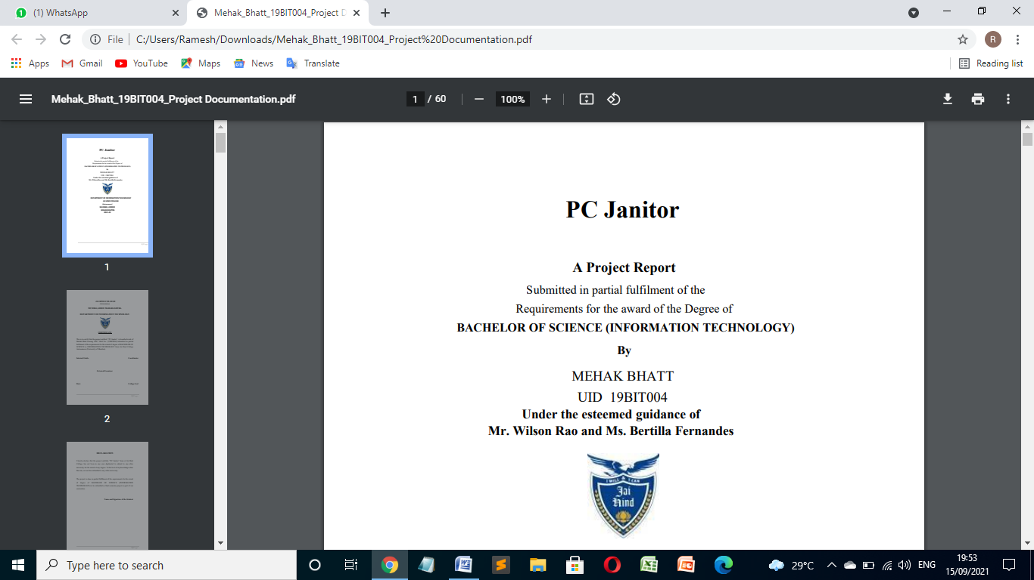

**DEPARTMENT OF INFORMATION TECHNOLOGY**

**JAI HIND COLLEGE**

**(Autonomous)**

**MUMBAI, 400020**

**MAHARASHTRA**

**2022-23**

**JAI HIND COLLEGE**

**(Autonomous)**

**MUMBAI, 400020**

**MAHARASHTRA**

**DEPARTMENT OF INFORMATION TECHNOLOGY**

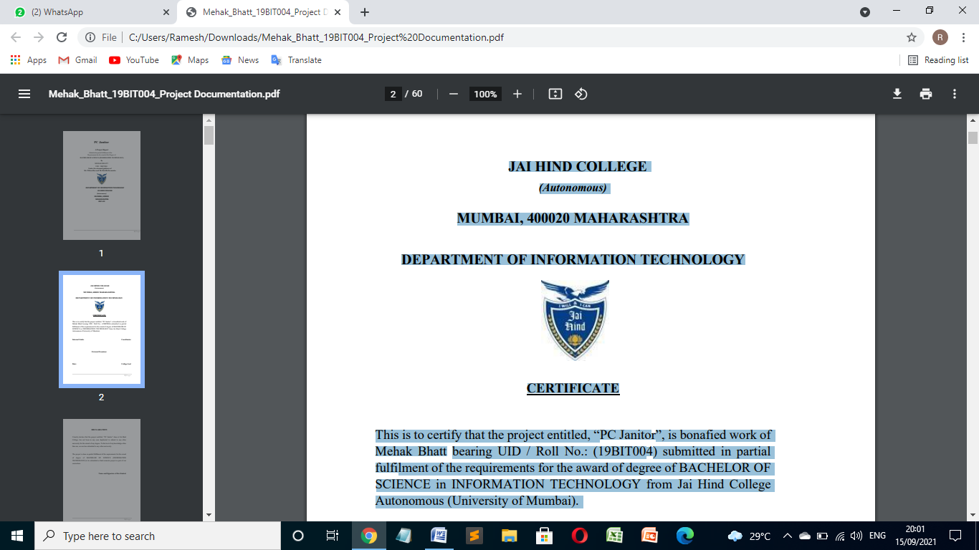

**CERTIFICATE**

This is to certify that the project entitled, “AI Face Recognition Attendance System”, is bonafied work of Ramesh Chauhan bearing UID / Roll No.: (19BIT007) submitted in partial fulfillment of the requirements for the award of degree of BACHELOR OF SCIENCE in INFORMATION TECHNOLOGY from Jai Hind College Autonomous (University of Mumbai).

**Internal Guide Coordinator**

**External Examiner**

**Date: College Seal**

**DECLARATION**

I hereby declare that the project entitled, “AI Face Recognition Attendance System” done at Jai Hind College, has not been in any case duplicated to submit to any other university for the award of any degree. To the best of my knowledge other than me, no one has submitted to any other university.

The project is done in partial fulfilment of the requirements for the award of degree of BACHELOR OF SCIENCE (INFORMATION TECHNOLOGY) to be submitted as final semester project as part of our curriculum.

**Name and Signature of the Student**

**ACKNOWLEDGEMENT**

I am extremely grateful for the guidance of our Head of Department (Information Technology & Software Development) Mr. Wilson Rao. Sir had great involvement in making sure my project is a well-rounded and a flawless system by constantly guiding us till the completion of our project work by providing all the necessary information for developing a good system.

I would like to express immense gratitude to the people who have helped me throughout the course of my project. I am grateful to Prof. Ms. Bertilla Fernandes for her constant encouragement and support.

I would also like to thank all of my friends and my seniors who supported and helped me in completing the project, where they all had their own interesting takes on the technology stack, and the own interesting ideas on how to finesse the system even further. I would also like to thank my family for their constant support and encouragement.

**Abstract**

Face recognition is among the most productive image processing applications and has a pivotal role in the technical field. Recognition of the human face is an active issue for authentication purposes specifically in the context of attendance of students. Attendance system using face recognition is a procedure of recognizing students by using face biostatistics based on the high definition monitoring and other computer technologies. The development of this system is aimed to accomplish digitization of the traditional system of taking attendance by calling names and maintaining pen-paper records. Present strategies for taking attendance are tedious and time-consuming. Attendance records can be easily manipulated by manual recording. After face recognition attendance reports will be generated and stored in excel format. The system is tested under various conditions like illumination, head movements, the variation of distance between the student and cameras. After vigorous testing overall complexity and accuracy are calculated. The Proposed system proved to be an efficient and robust device for taking attendance in a classroom without any time consumption and manual work. The system developed is cost-efficient and need less installation.

**TABLE OF CONTENTS**

**1. INTRODUCTION**

**1.1 Background……………………………………………….................................8**

**1.2 Objectives……………………………………………………………………....9**

**1.3 Purpose, Scope, and Applicability…………………………………………...10**

**1.3.1 Purpose………………………………………………………………….....10**

**1.3.2 Scope…………………………………………………………………….....10**

**1.3.3 Applicability………….…………………………………………………....10**

**1.4 Achievements………………………………………………………………......11**

**1.5 Organization of Report………………………………………………………..12**

**2. SURVEY OF TECHNOLOGIES 13**

**3. REQUIREMENT AND ANALYSIS 15**

**3.1 Problem Definition……………………………………………………………...15**

**3.2 Requirement Specification……………………………………………………..15**

**3.3 Planning and Scheduling……………………………………………………….16**

**3.4 Software and Hardware Requirements……………………………………….17**

**3.5 Preliminary Product Description……………………………………………....18**

**3.6 Conceptual Models……………………………………………………………...19**

**4. SYSTEM DESIGN 27**

**4.1 Basic Modules…………………………………...................................................27**

**4.2 User Interface Design…………………………………………………………...29**

**4.3 Security Issues……………………………………………..................................36**

**4.4 Test Cases Design…………………………………………….............................37**

**5. IMPLEMENTATION AND TESTING 40**

**5.1 Implementation Approach…………………………………………………….40**

**5.2 Coding Details and Code Efficiency…………………………………………...43**

**5.3 Testing Approach………………………………………….................................59**

**5.3.1 Unit Testing………………………………………….....................................59**

**5.3.2 Integration Testing………………………………………….........................59**

**5.3.3 System Testing…………………………………………................................59**

**5.3.4 Validating Testing…………………………………………..........................59**

**5.3.5 Output Testing…………………………………………................................59**

**5.3.6 User Acceptance Testing…………………………………………................59**

**5.4 Modifications and Improvements……………………………………………...60**

**6. RESULTS AND DISCUSSION 61**

**6.1 User Documentation…………………………………………………...............61**

**7. CONCLUSION 72**

**7.1 Conclusion……………………………………………………...........................72**

**7.2 Limitations of the System……………………………………………...............72**

**7.3 Future Scope of the Project………………………………………....…............72**

**List of Figures**

1. Gantt Chart…………………………………………………………….....16

2. PERT Chart……………………………………………………………....16

3. Event Table……………………………………….……………………....19

4. ER Diagram................................................................................................20

5. Class Diagram……………………………………………………….........21

6. Activity Diagram………………………………………………................22

7. Sequence Diagram………………………………………………...……...23

8. Use Case Diagram………………………………………………………..23

9. State Diagram…………………………………………………………....24

10. Package Diagram…………………………………………………….….24

11. Deployment Diagram…………………………………………………....25

12. Component Diagram…………………………………………………….25

13. Data Flow Level 0 Diagram……………………………………………..26

14. Home page…………………………………………….............................62

15. Teacher Registration Page………………………………………….........62

16. Admin Login Page…………………………………………….................63

17. Student Registration page……………………………………………......64

18. Teacher Login Page……………………………………………...............66

19Attendance panel Page.……………………………………………............67

20. Report Page……………………………………………............................68

**Chapter-1:- INTRODUCTION**

**1.1] Background:-**

Every organization requires a robust and stable system to record the attendance of their students. and every organization have their own method to do so, some are taking attendance manually with a sheet of paper by calling their names during lecture hours and some have adopted biometrics system such as fingerprint, RFID card reader, Iris system to mark the attendance. The conventional method of calling the names of students manually is time consuming event. The RFID card system, each student assigns a card with their corresponding identity but there is chance of card loss or unauthorized person may misuse the card for fake attendance. While in other biometrics such as finger print, iris or voice recognition, they all have their own flaws and also they are not 100% accurate.

Use of face recognition for the purpose of attendance marking is the smart way of attendance management system. Face recognition is more accurate and faster technique among other techniques and reduces chance of proxy attendance. Face recognition provide passive identification that is a person which is to be identified does not to need to take any action for its identity. Face recognition involves two steps, first step involves the detection of faces and second step consist of identification of those detected face images with the existing database. There are number of face detection and recognition methods introduced. Face recognition works either in form of appearance based which covers the features of whole face or feature based which covers the geometric feature like eyes, nose, eye brows, and cheeks to recognize the face.

Our system uses face recognition approach to reduce the flaws of existing system with the help of machine learning, it requires a good quality camera to capture the images of students, the detection process is done by histogram of oriented gradient. And recognizing performs through deep learning.

**1.2] Objectives:**

* To detect the face segment from the video frame.
* To extract the useful features from the face detected.

• To classify the features in order to recognize the face detected.

• To record the attendance of the identified student.

**1.3] Purpose, Scope, and Applicability**

**1.3.1] Purpose:-**

The motivation behind this proposed work comes from the advancement of technologies like image processing, AI and machine learning and Face unlock feature given by smart-phone manufacturers. The classroom often consists of huge number of students which usually takes a lot of time thus creating a system which will automatically detect the present students and then marking the students accordingly will be very helpful, Just like staff Id scanning but way too easier than that. This system will also reduce manipulation of attendance records by the students.

**1.3.2] Scope:-**

* Automating the whole process so that we have digital environment.
* Use the Live face Recognition to recognize each individual and mark their attendance automatically.
* Utilizes video and image processing to provide input to the system
* Automate update in the attendance sheet without human intervention.
* To keep the student update with their attendance ratio.

**1.3.3] Applicability:-**

1. To verify identities in Government organizations.

2. Enterprises.

3. Attendance in Schools and colleges.

4. To detect fake entries at international borders.

5. Industries.

**1.4] Achievements:-**

There is also problem that student can mark their friends attendance by showing their photo from mobile i.e. spoof attack.

For spoof detection I am using tensor flow inception model by retraining it's last layer so that it can detect mobile phones in an image.

**1.5] Organization Report**

* **Requirement Specification**
* **Functional Requirements**
* The system has different functionalities for an admin and teachers. Admin has higher privileges than teachers. Taking and tracking student attendance by facial recognition in specific time.
* Sending the names of the absent student directly to the respective parents via email.

**Admin Module**

Admin has the highest privileges among all as admin is responsible to design the system. Admin register teacher and provide unique id to the teacher. They are responsible to take images of the students and add them to the database. Admin can view and update the details of both students and teachers. They can also view the attendance report

**Teacher Module**

Teachers can log in to the system. They can open the application and the images of the students for attendance. They can also view the attendance report.

**2] Survey of Technology:**

**Project contains two websites developed using flask and python3.**

Flask is a web application framework written in Python. Flask is based on Werkzeug WSGI toolkit and Jinja2 template engine. Both are Pocco projects. Python 2.6 or higher is usually required for installation of Flask. Although Flask and its dependencies work well with Python 3 (Python 3.3 onwards), many Flask extensions do not support it properly. Hence, it is recommended that Flask should be installed on Python 2.7.

**Install virtualenv for development environment**

**Virtualenv** is a virtual Python environment builder. It helps a user to create multiple Python environments side-by-side. Thereby, it can avoid compatibility issues between the different versions of the libraries.

**The following command installs virtualenv**

pip install virtualenv

virtualenv venv

**To activate corresponding environment:-**

venv\scripts\activate

**We are now ready to install Flask in this environment.**

pip install Flask

**In order to test Flask installation, type the following code in the editor as Hello.py**

from flask import Flask

app = Flask(__name__)

@app.route('/')

def hello_world():

return 'Hello World’

if __name__ == '__main__':

app.run()

**Database used : MySQL community edition.**

1. For face reocognition I used python3 "face_recogntion" by ageitgey. Built using dlib's state-of-the-art face recognition built with deep learning. The model has an accuracy of 99.38% on the Labeled Faces in the Wild benchmark.
2. For spoof detection I used tensorflow inception model by retraining it's last layer so that it can detect mobile phones in an image.
3. To generate and manage excel I used xlrx and xlrd and pandas.
4. For sending email's I used flask-mail.
5. admin site dependency : flask, mysqlclient, sklearn, numpy, scipy, pillow, dlib, face_recognition
6. teachers site dependency : flask_bootstrap, pytz, xlsxwriter, pandas, flask_mail, tensorflow,xlrd

Image Acquisition: The system consists of a camera on a mobile/laptop/Computer that captures the images of the student and sends it to the image pre-processing. Then that image is sends for face detection.

B. Face Detection: This process separates the facial area from the rest of the background image. The faces which are stored in the database.

C. Feature Extraction: Feature extraction is done for distinguishing faces of different student. In this system, eyes, nose and mouth are extracted. Feature extraction is helpful in face detection and recognition.

D.Face Recognition: The face image is then compared with the stored image. If the face image is matched with the stored image then the face is recognized. Then for that particular student the attendance is recorded.

**3] Requirement analysis:**

**3.1] Problem Definition:**

Taking and tracking students’ attendance manually, losing attendance sheets, dishonesty, wasted time and high error scales are problems facing the lecturers use the existing attendance system. It is a hard process, take time and cause a lot of paper-based work. As a result, in order to solve these problems and avoid errors we suggest computerizing this process by providing a system that record and manage students’ attendance automatically without needing to lecturers’ interference.

**3.2] Requirement Specification:**

**3.2.1] Functional Requirements:-**

After getting valuable information we reached to the following important conclusions: -

1. It should meet the functional requirements as mentioned in Objectives.  
2. It should be able to handle 'png,jpg' and 'jpeg' imges.

**3.2.2] Non-functional Requirements:-**

This project is intended to meet the following non functional requirements: -

1) This face recognition software should be available on the Internet, to enable the users to use, download it any time.  
2) The program should be platform independent.

**3.3] Planning and Scheduling**

**Pert Chart**

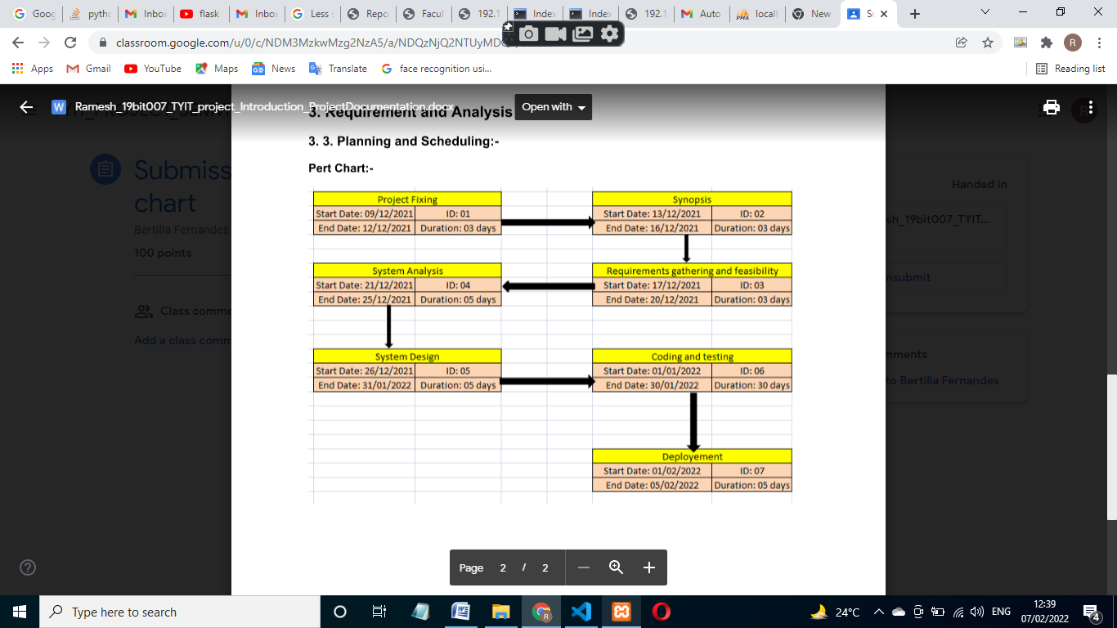

**Gantt Chart:-**

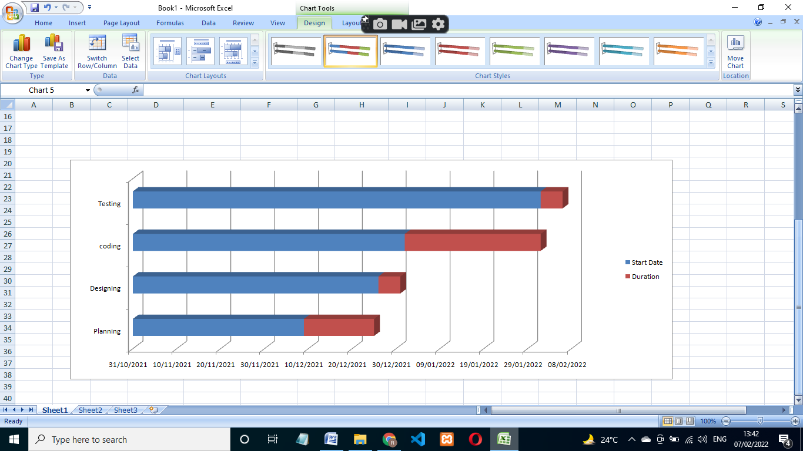

**3.4] Software and Hardware Requirement**

**Hardware**

|  |  |
| --- | --- |
| Processor | Intel@ Pentium quad core |
| Memory | 4GB |
| ROM | 1TB |

**Software:-**

|  |  |
| --- | --- |
| IDE | VsCode |
| Language | Html+Css+JavaScript+Python+Flask |
| Database | Mysql |
| Operating system | Windows 10 |

**3.5] Preliminary Product Description:-**

**Modules:-1) Admin Home page**:-System initiate with admin home screen. Here user will get 2

Navigation tab as admin login and Teacher Register. Admin can login with register credential. Admin first need to register the teacher.

**Modules:- 2) Teacher Registration:** Admin first need to Register the teacher then he/she will get access of Admin-site. Here admin needs to put name, email, and password to register the account.

**Modules:- 3) Admin Login:** Admin need to first login to account to get access of Student registration form. Here admin will need to put username and password to login. While username and password must match to registration username and password. Otherwise admin won’t able to login into system

.

**Module:-4) Student Registration**: After admin login successfully he/she will get access of student registration page. Admin need to first register the student details and also upload the picture of student while registration to create the model of that particular student.

**Teacher-site:-**

**Module-5) Teacher Login:** Now using teacher's site (It will be used when teacher will actually enter the class), teacher has to login first.

**Module:-6) Attendace panel:**- After teacher successfully login teacher will get two options attendance panel and report panel.after clicking on attendance tab there will be no back button as teacher will pass on the phone to student.Student's will then have to just click a snap enter class and roll id and press enter to mark their attandance.

After that there is also a problem of spoof attack in face recognition i.e. someone will show someone's image of face through their mobile phone and trick our webapp and they will mark the attendace of their friends who were not present.

But I solved this issue using tensorflow, by training inception to detect mobile phones in an image then I used that model in the webapp as soon as student's click a snap it will first check if the face is spoof or original. To retrain inception's last layer I used 200 images of mobile phones and I feed them to tensorflow to retrain the last layer of inception.

**Module:-8) View Report:** Now after student's part is done. Teacher can then login again and then go to report's tab to see attendance. Here there are several option's I have given. If teacher want to see today's attendace, just select date and time to see the attendance. And there is also an option to download the attendace sheet in excel form and then again reupload it after making any changes if sometime required by the teacher. And the teacher can also see total attendance for his or her lecture. so that they can analyze how many lectures each student from particular class had attended so far.

One additional feature is that teacher can send email for the attendance marked to all the parents as well as students by selecting class and clicking on send mail button.

**3.6] Conceptual Models**

**Event Table:**

|  |  |  |  |  |  |  |
| --- | --- | --- | --- | --- | --- | --- |
| Sr No. | Event | Trigger | Source | Activity | Response | Destination |
| **Admin-site** | | | | | | |
| 1 | Teacher-Registration | Registration request | website | Email and password authentication | Account created successful or not | Mysql |
| 2 | Student-Registration | Registration Request | website | Name and student email- id and parent- email id get register and roll no | Register successfully or not | Mysql |
| 3 | Student model-image Training | Image upload | website | Creating training data | Model get created | Mysql |

|  |  |  |  |  |  |  |
| --- | --- | --- | --- | --- | --- | --- |
| Sr No. | Event | Trigger | Source | Activity | Response | Destination |
| **Teacher-site** | | | | | | |
| 1 | Teacher-Login | Login request | website | username and password credential check | Login with register credential or not | Mysql |
| 2 | Attendance panel | Face Recognition | website | Proper face recognition | Face match or not with the database image | Mysql |
| 3 View-Report panel | | excel sheet  generate | website | Excel sheet  download | download | excel |
| Send mail to parent | website | Sending mail | Received or not | Gmail.com |

**Admin-site**

**Admin ER Diagram:-**

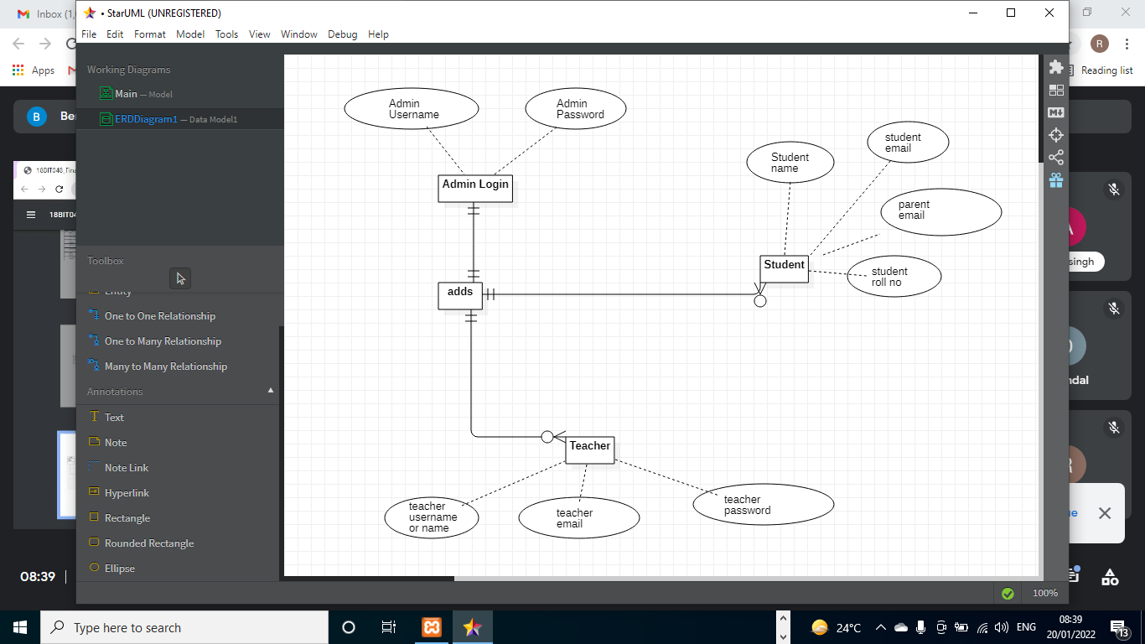

**Teacher-site**

**Teacher-ER diagram:-**

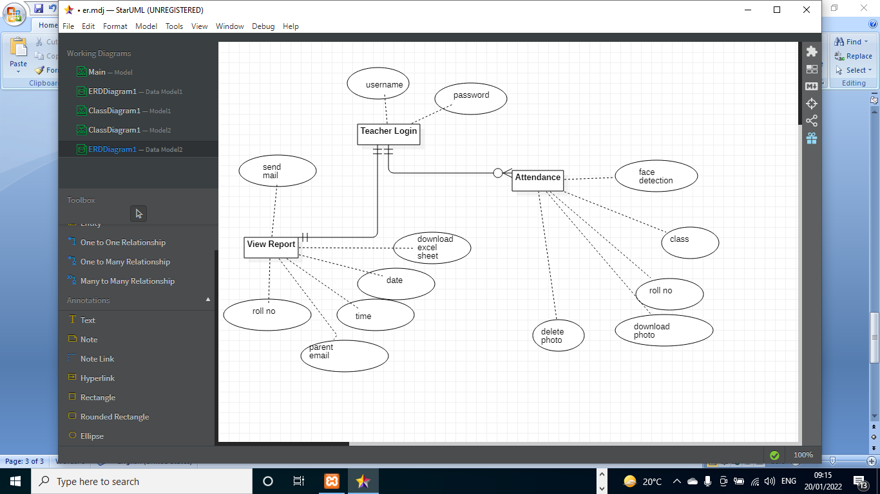

**Admin Class diagram**

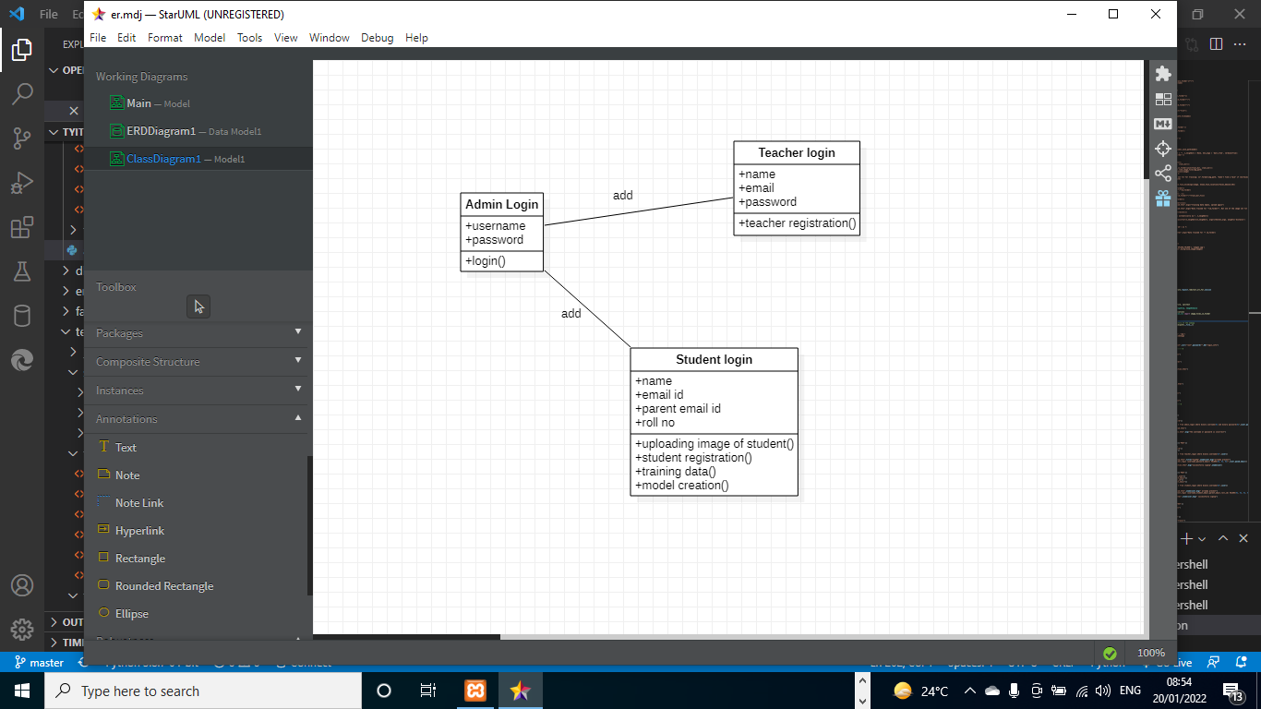

**Teacher-site Class diagram:**

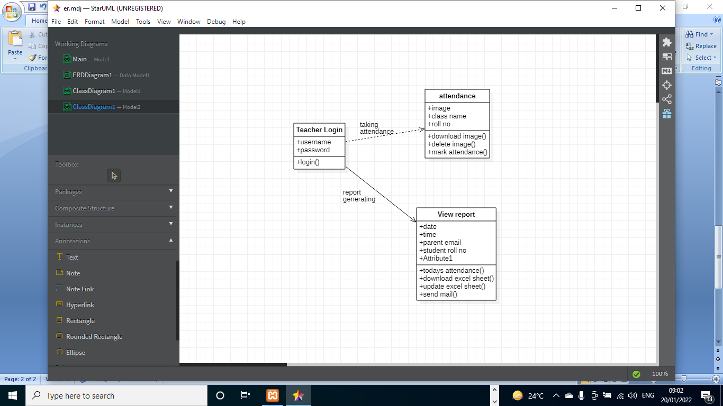

**Activity diagram:-**

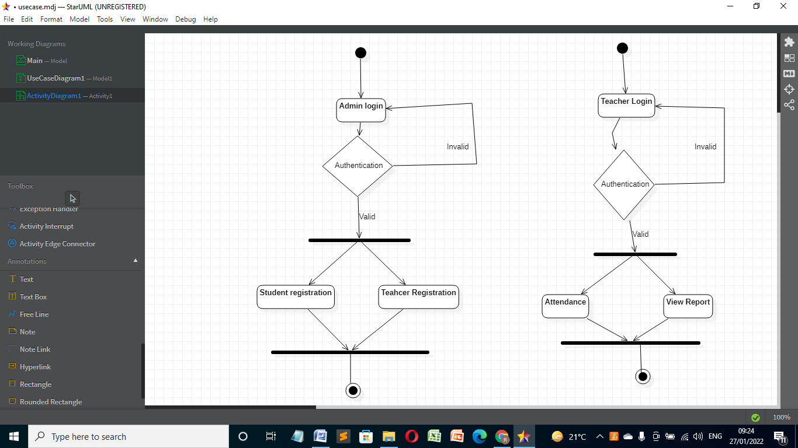

**Sequence Diagram:**

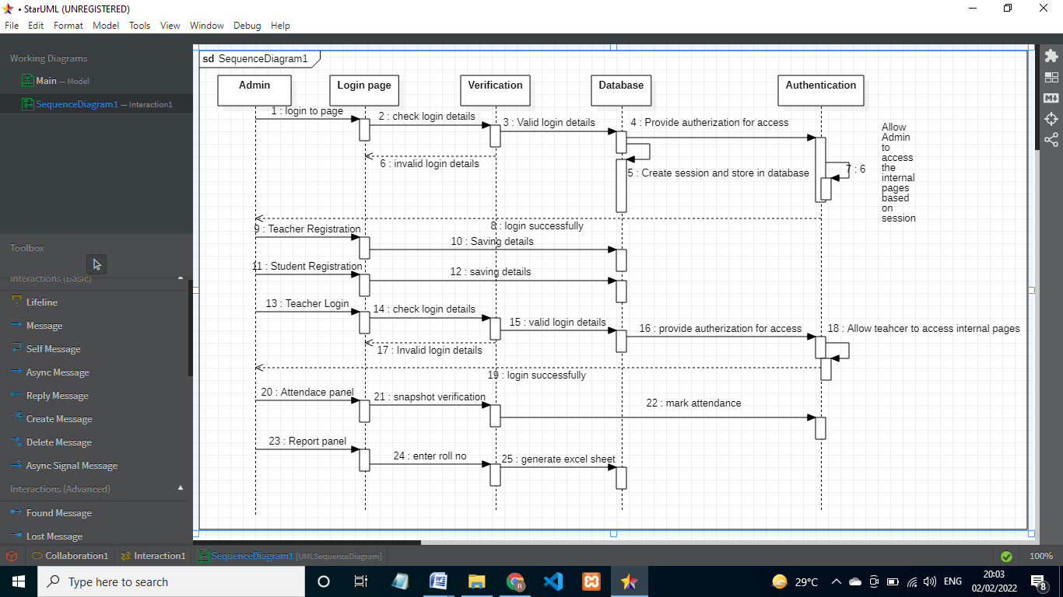

**USE CASE:-**

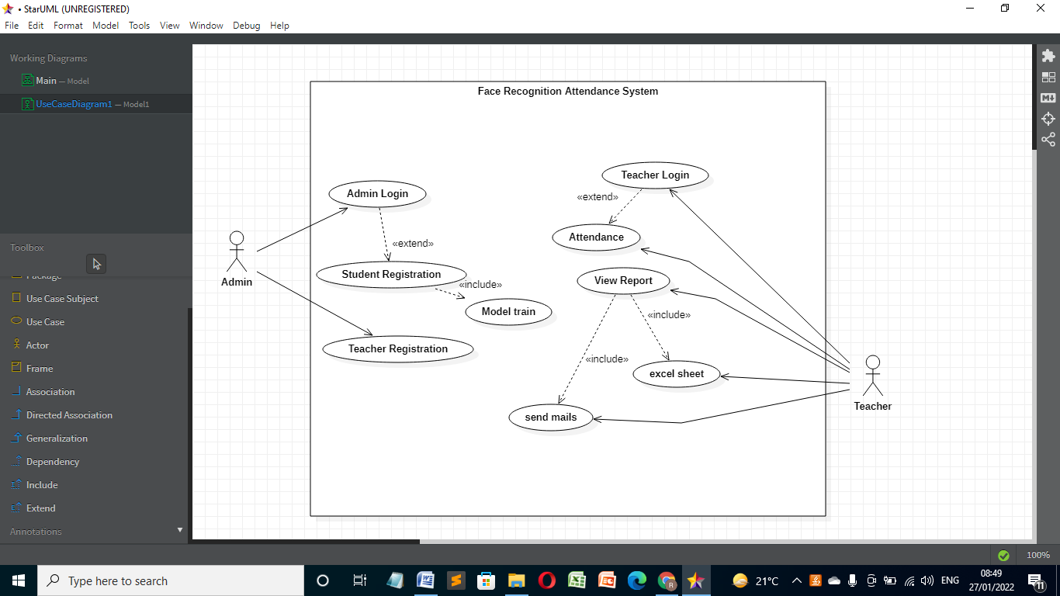

**Statechart**

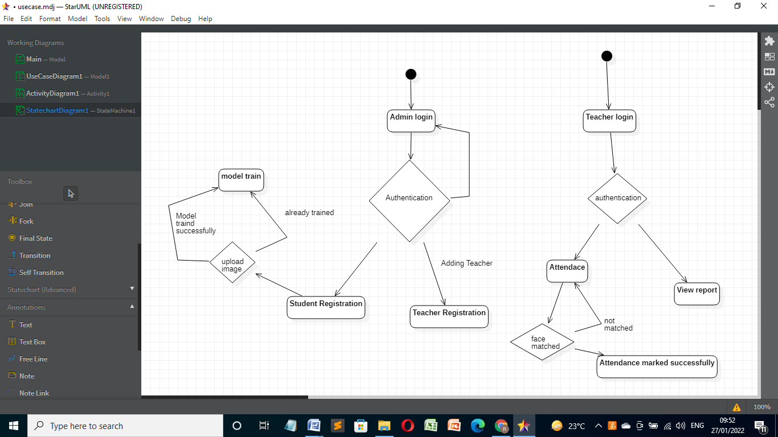

**Package Diagram:-**

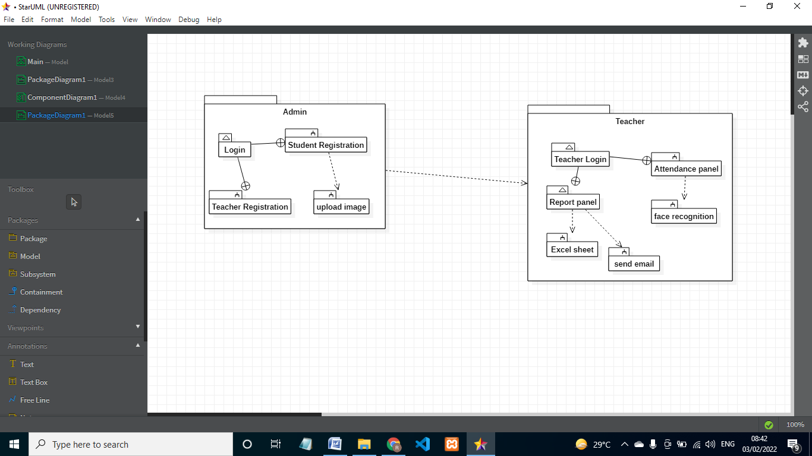

**Deployment diagram:**

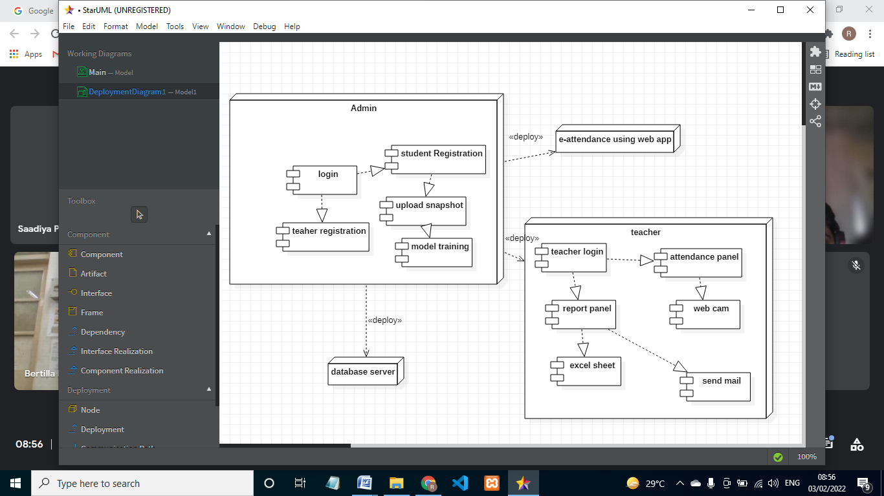

**Component diagram**

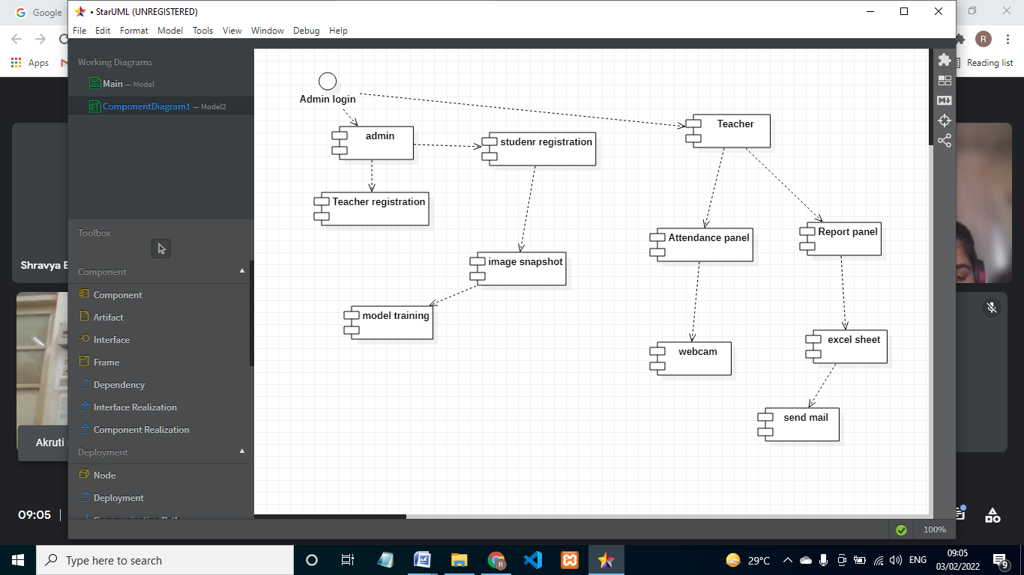

**DFD:**

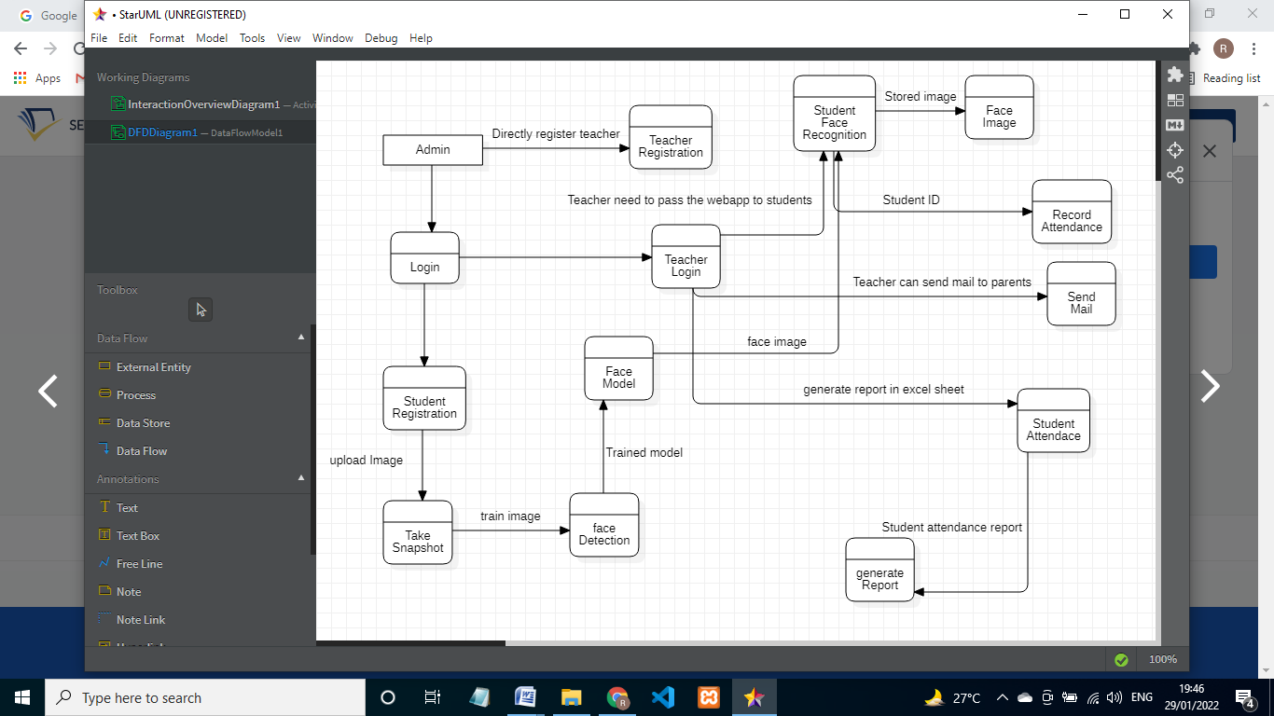

**4] System Design**

**4.1] Basic Module**

Project contains two webapp's developed using flask and python3. Database used : MySQL community edition. For face reocognition I used python3 "face_recogntion" by ageitgey.(<https://github.com/ageitgey/face_recognition>), Built using dlib's state-of-the-art face recognition built with deep learning. The model has an accuracy of 99.38% on the Labeled Faces in the Wild benchmark.

For spoof detection I used tensorflow inception model by retraining it's last layer so that it can detect mobile phones in an image.

To generate and manage excel I used xlrx and xlrd and pandas.

For sending email's I used flask-mail.

admin site dependency : flask, mysqlclient, sklearn, numpy, scipy, pillow, dlib, face_recognition

teachers site dependency : flask_bootstrap, pytz, xlsxwriter, pandas, flask_mail, tensorflow,xlrd

**Admin Site:-**

**Home Page Module:-** Web application starts with home page module. Navigation bar contain three things Admin login , Teacher registration and contact page. It is static page.

**Admin Login Module:-** Admin is the super user. To access the Student Registration page Admin need to login first with Register Credentials.

**Teacher Registatrion module:-** Admin can also register teachers using this site.

**Student Registration and Model training Module:-** The whole concept is at the time of admission to college or school admin should register the students details such as his name email address and also create training data of each student by entering his roll id and taking snaps of his or her frontal face and then webapp will automatically create model for that particular roll id and save it on server, The model which is created for each student is about 8kb in size.

**Teachers Site:-**

**Teacher Login Page Module:-** Now using teacher's site (It will be used when teacher will actually enter the class), teacher has to login first to access the Attendace module.

**Attendance Module:-**Then after clicking on attendance tab there will be no back button as teacher will pass on the phone to student. Student's will then have to just click a snap enter class and roll id and press enter to mark their attandance.

After that there is also a problem of spoof attack in face recognition i.e. someone will show someone's image of face through their mobile phone and trick our webapp and they will mark the attendace of their friends who were not present.

But I solved this issue using tensorflow, by training inception to detect mobile phones in an image then I used that model in the webapp as soon as student's click a snap it will first check if the face is spoof or original. To retrain inception's last layer I used 200 images of mobile phones and I feed them to tensorflow to retrain the last layer of inception.

**View Report module:-** Now after student's part is done. Teacher can then login again and then go to report's tab to see attendance. Here there are several option's I have given.

If teacher want to see today's attendace, just select date and time to see the attendance. And there is also an option to download the attendace sheet in excel form and then again reupload it after making any changes if sometime required by the teacher. And the teacher can also see total attendance for his or her lecture. so that they can analyze how many lectures each student from particular class had attended so far.

**Send Mail module:-** One additional feature is that teacher can send email for the attendance marked to all the parents as well as students by selecting class and clicking on send mail button.

**4.2] User Interface**

**Admin Site**

**Homepage**

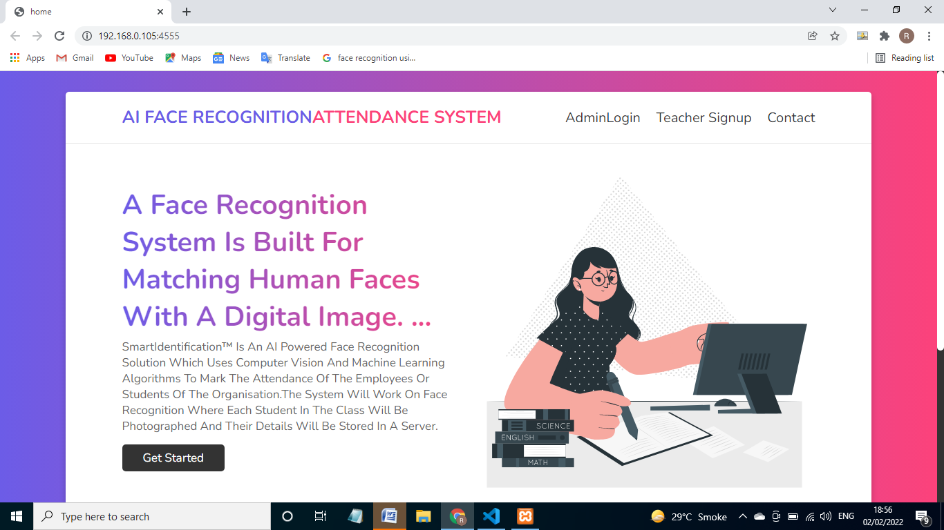

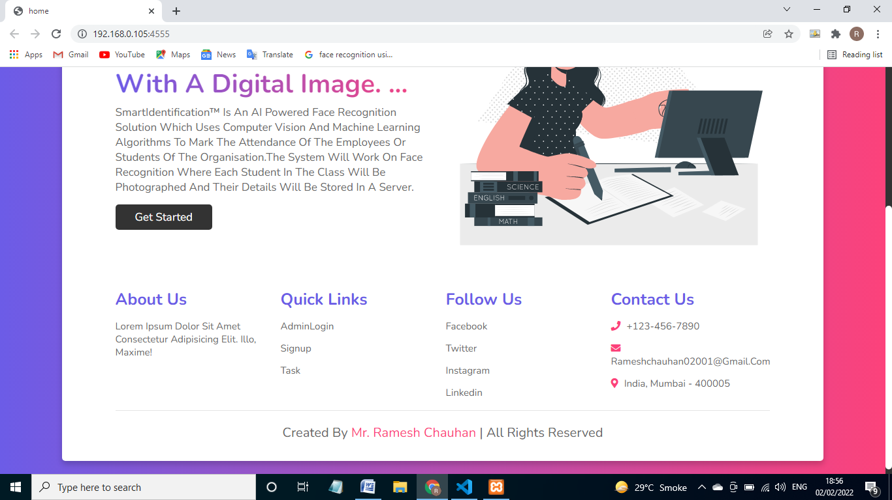

**Teacher Registration page:-**

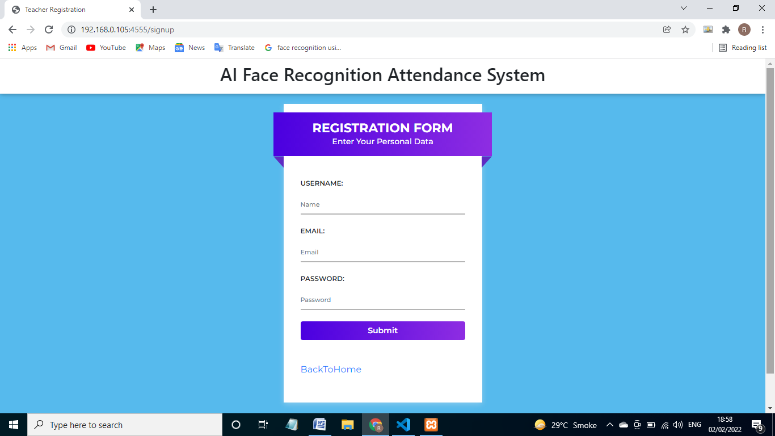

**Contact Page:-**

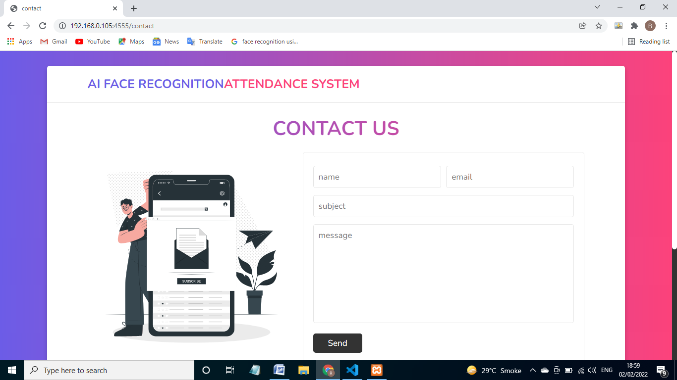

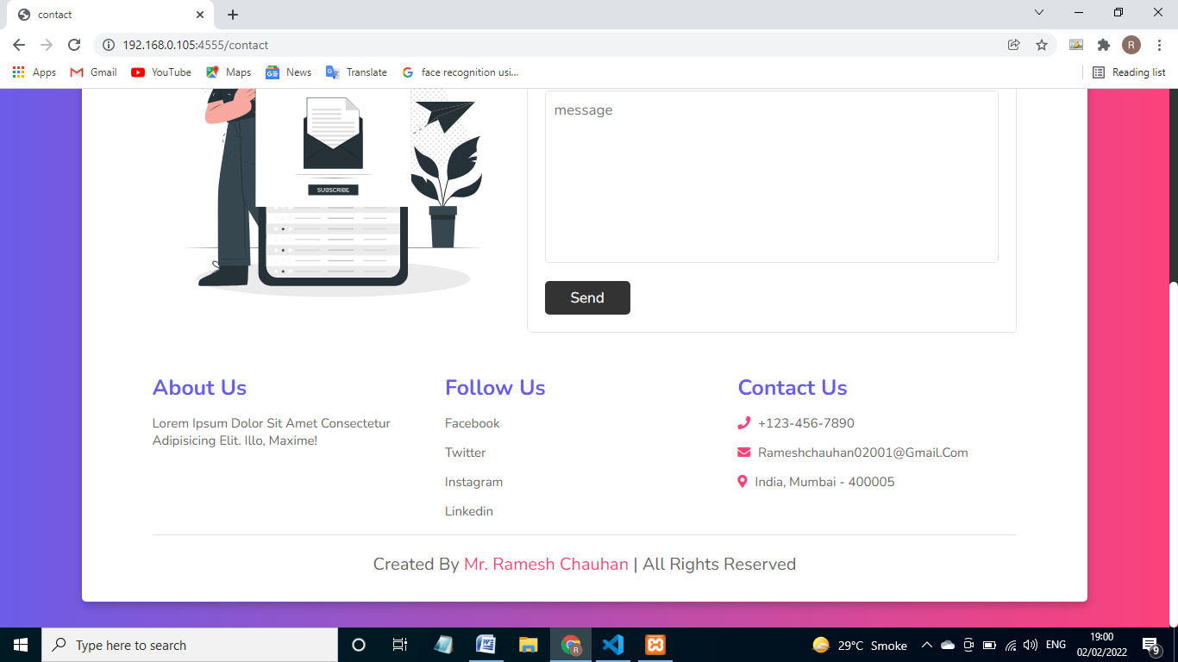

**Admin login Page**

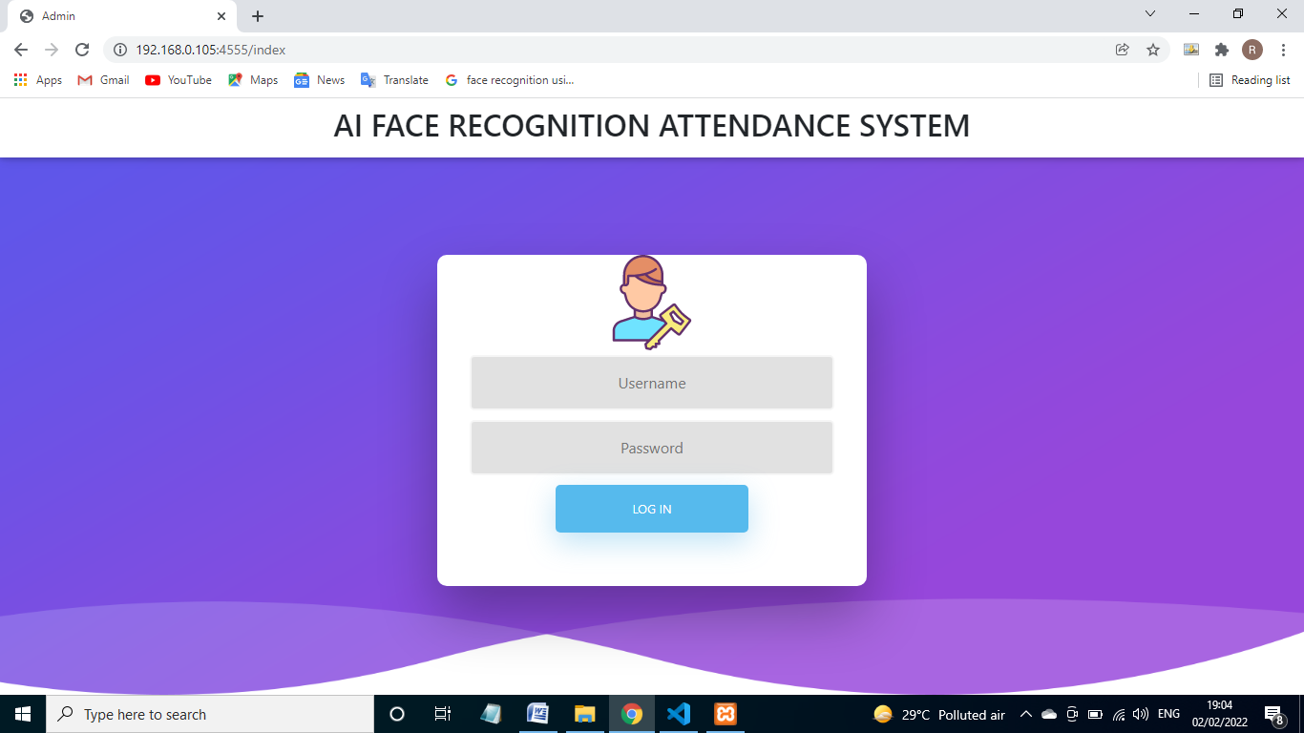

**Student Registration and Model Training Page**

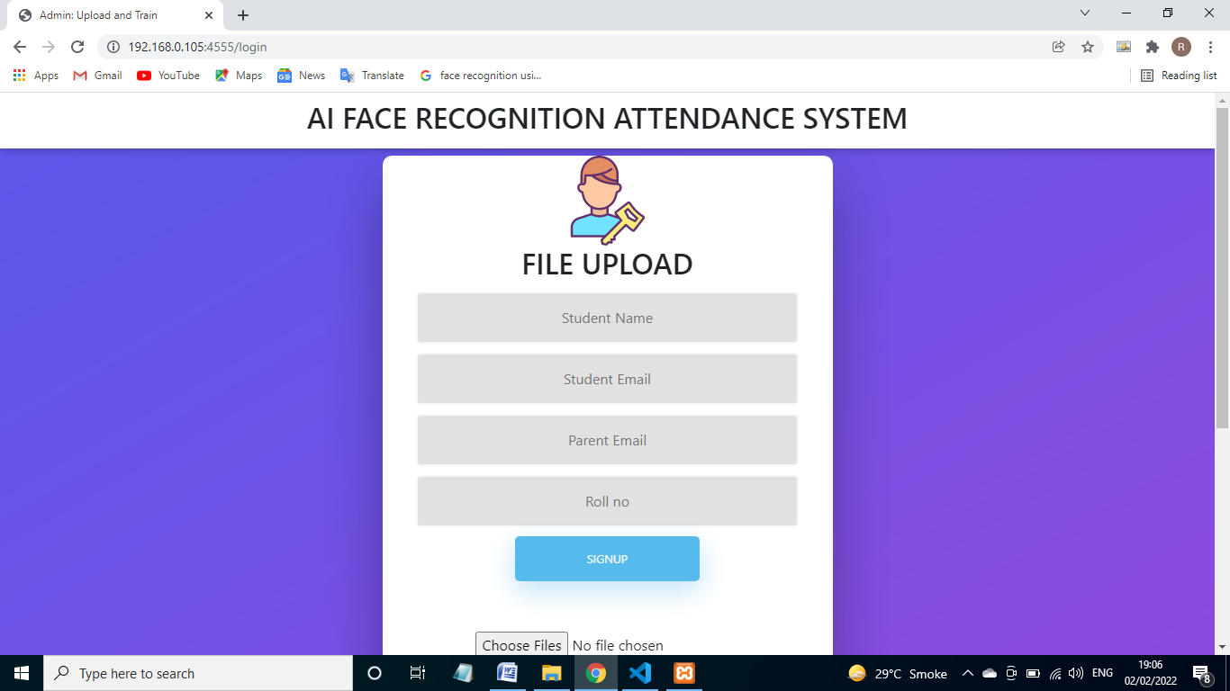

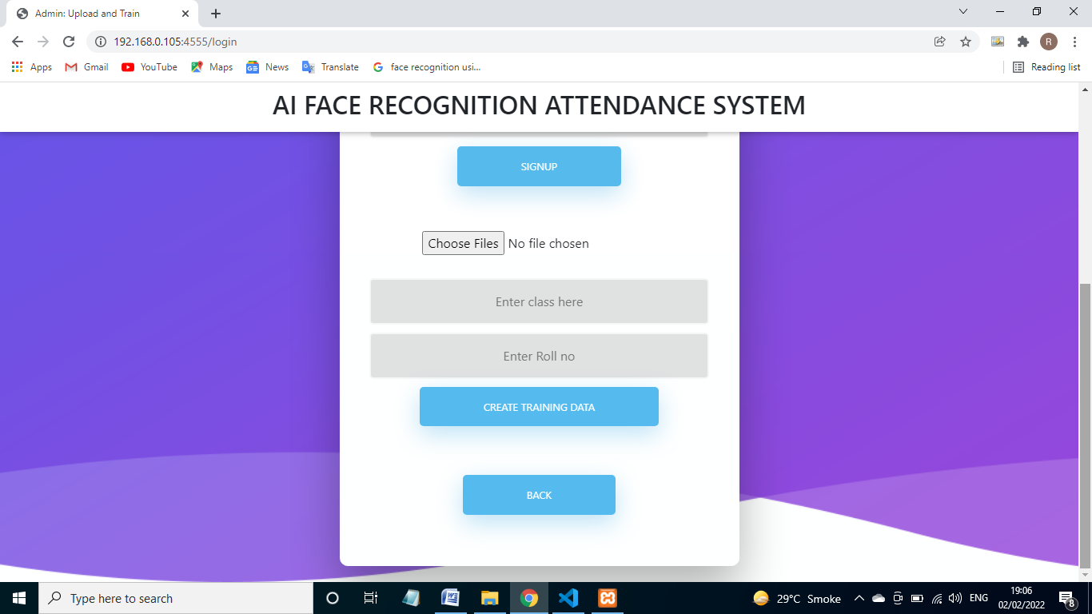

**Teachers Site:**

**Homepage:**

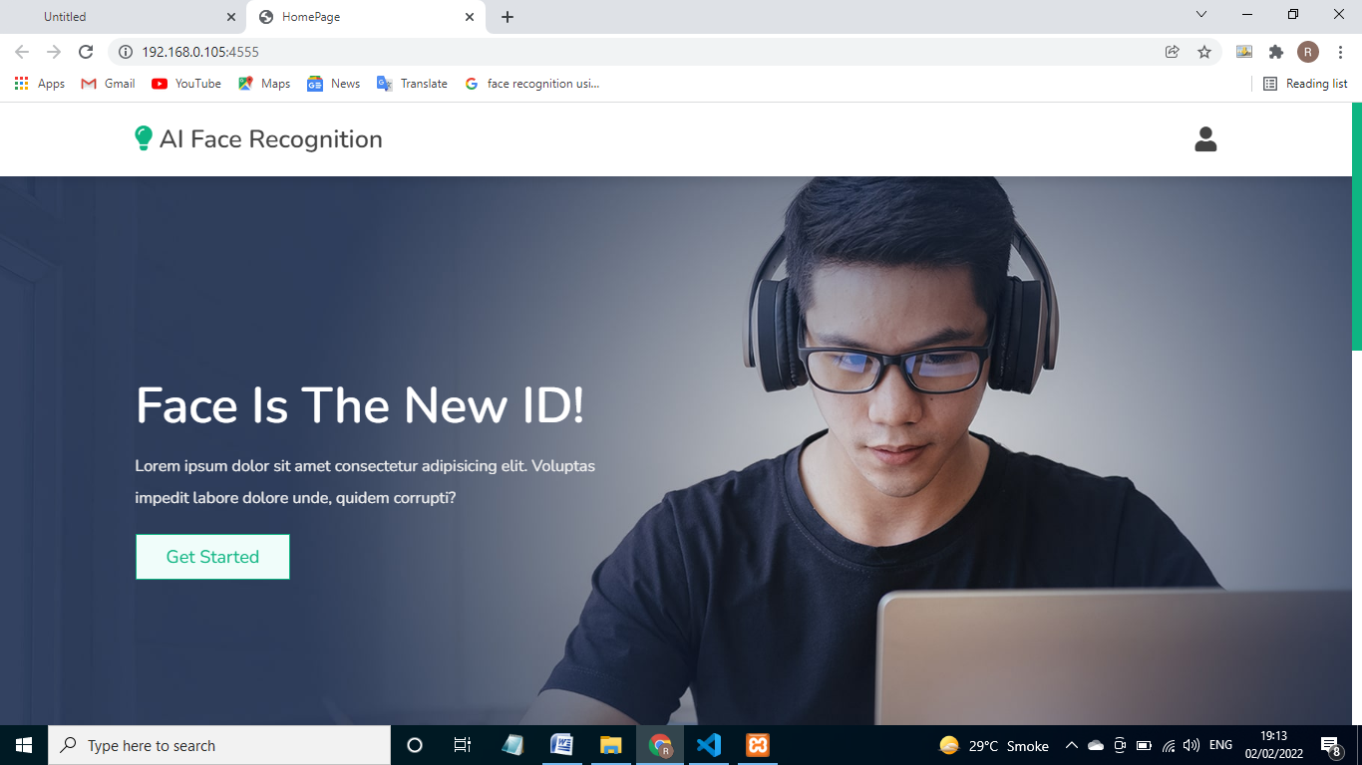

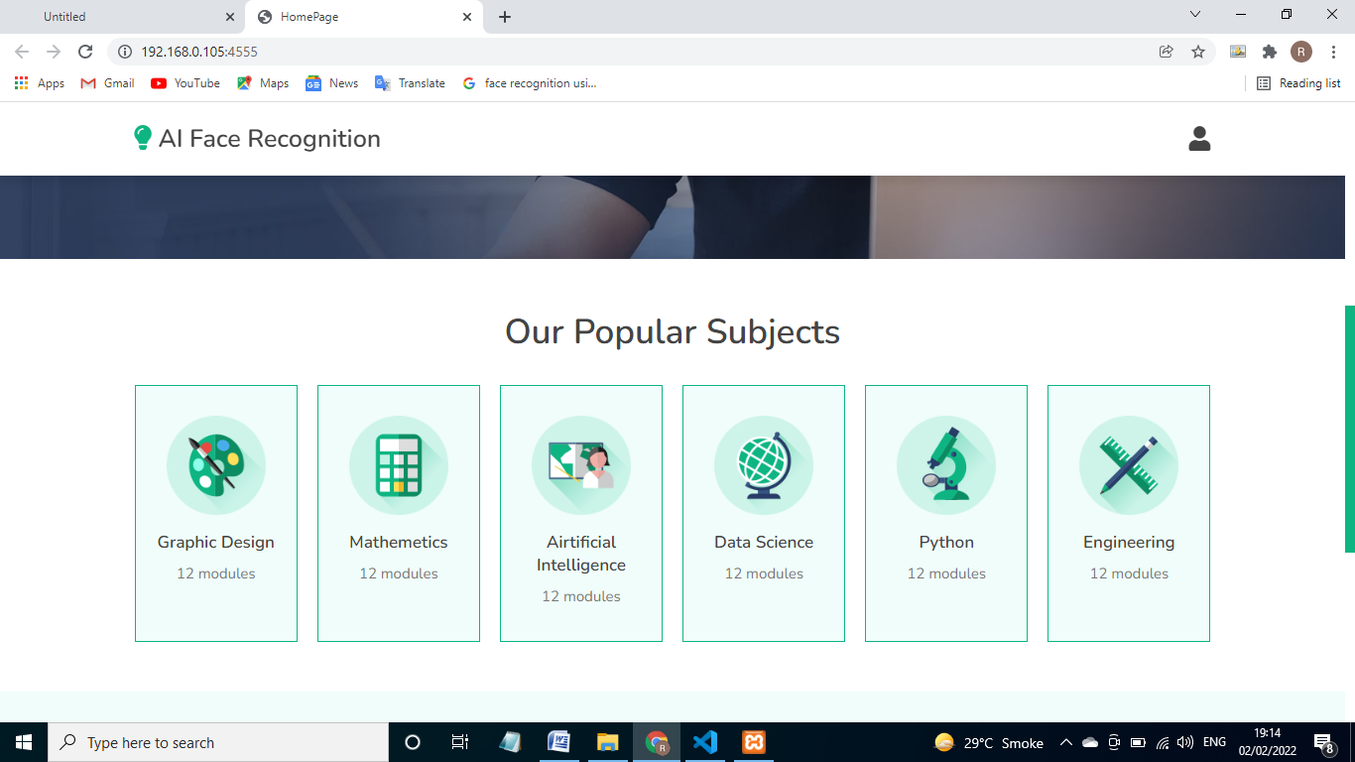

**LoginPage:**

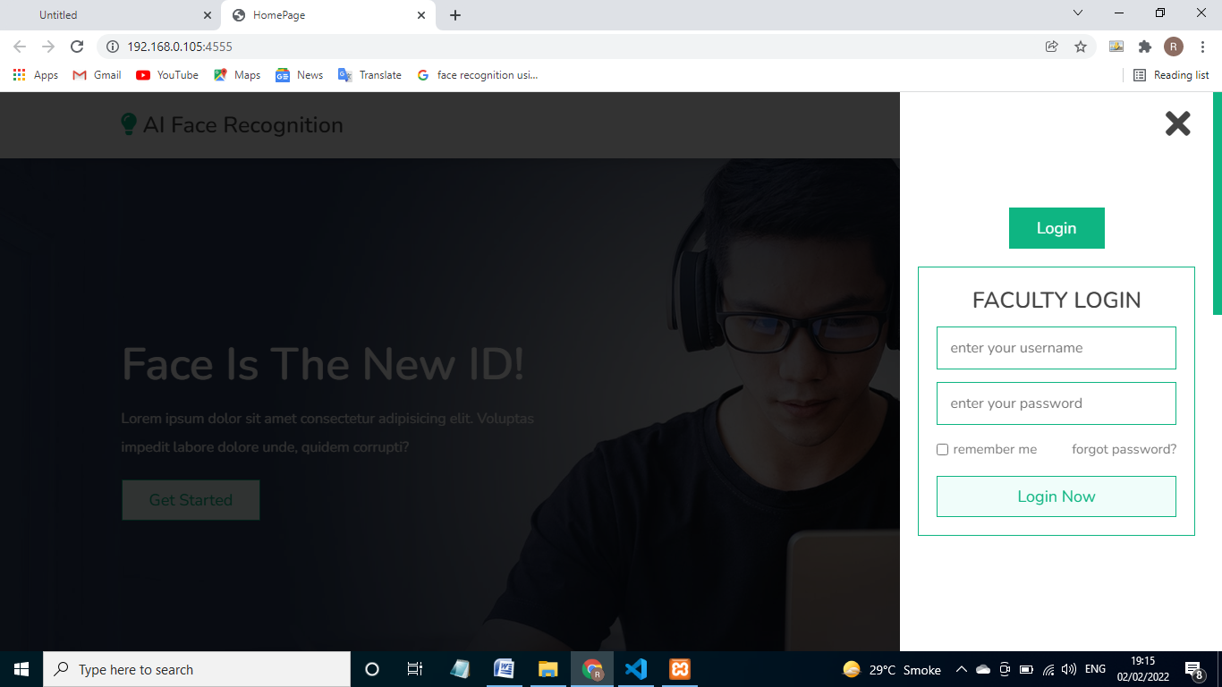

**TaskPage:**



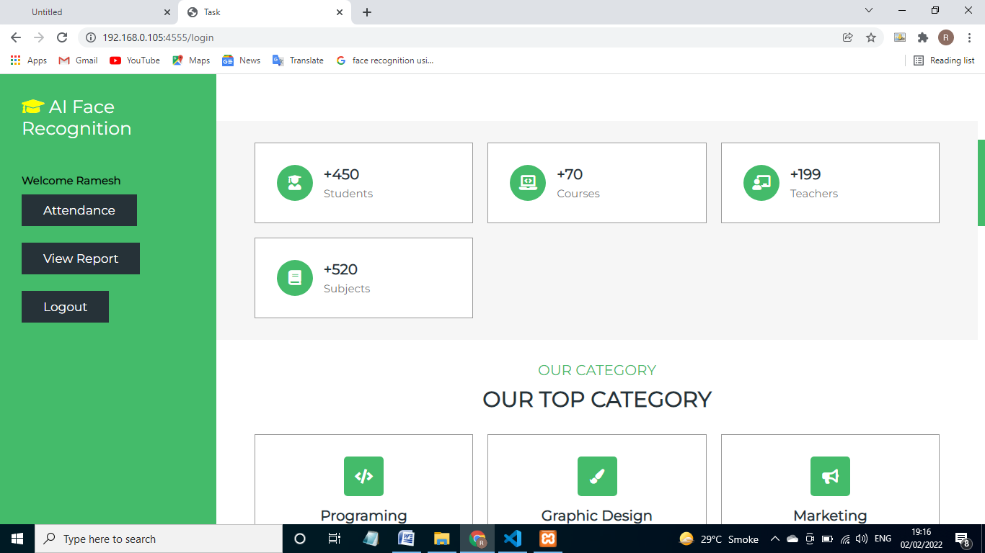







**AttendancePage:**

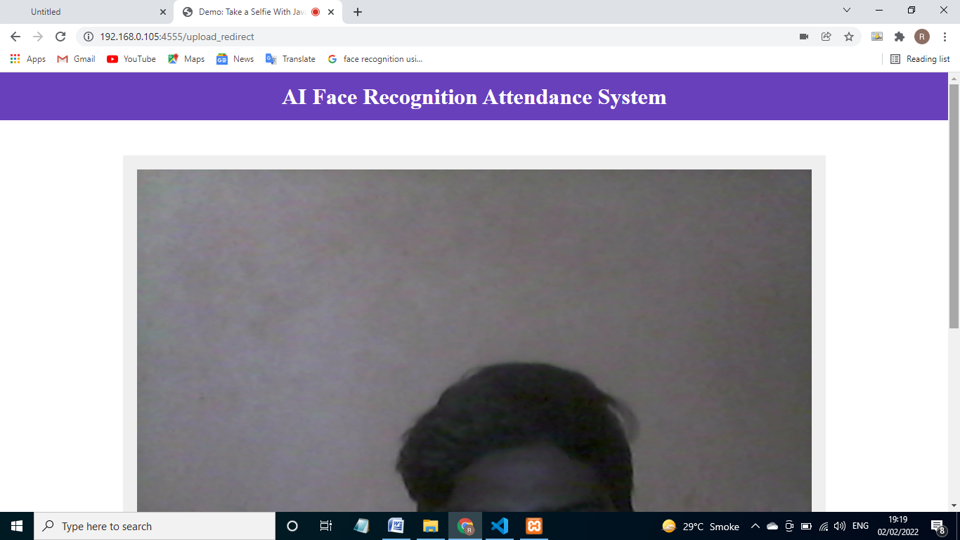

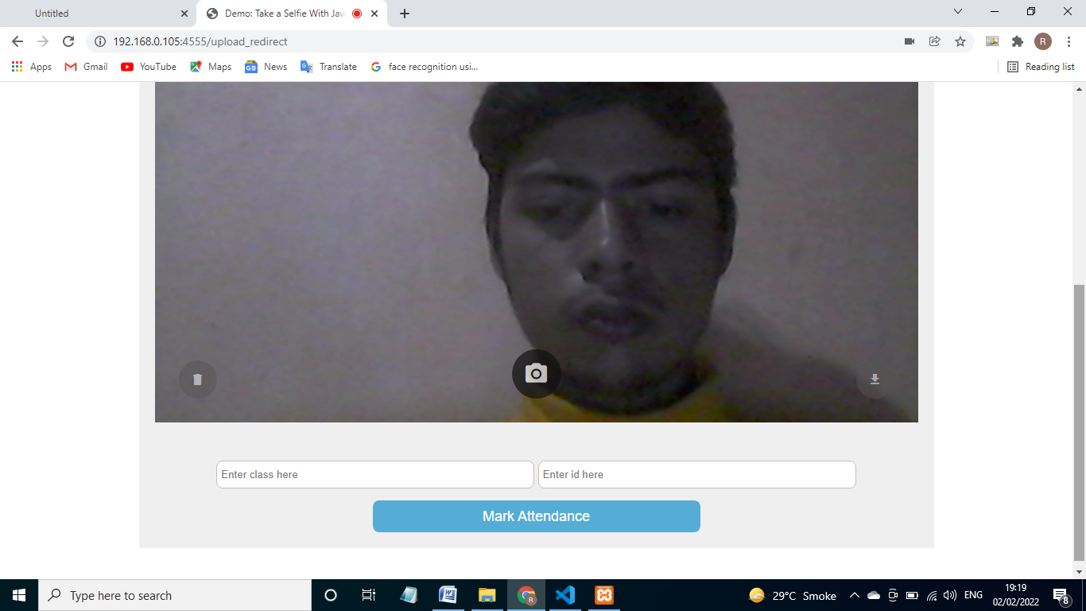

**View Report Page:**

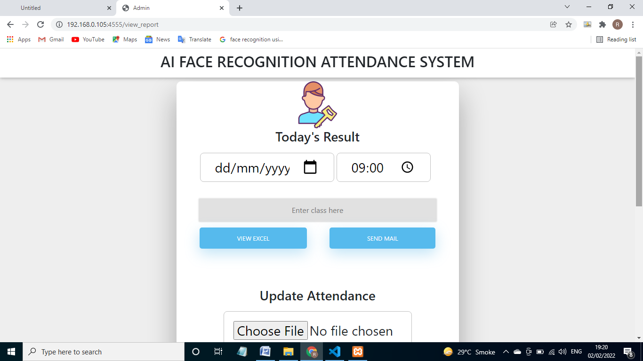

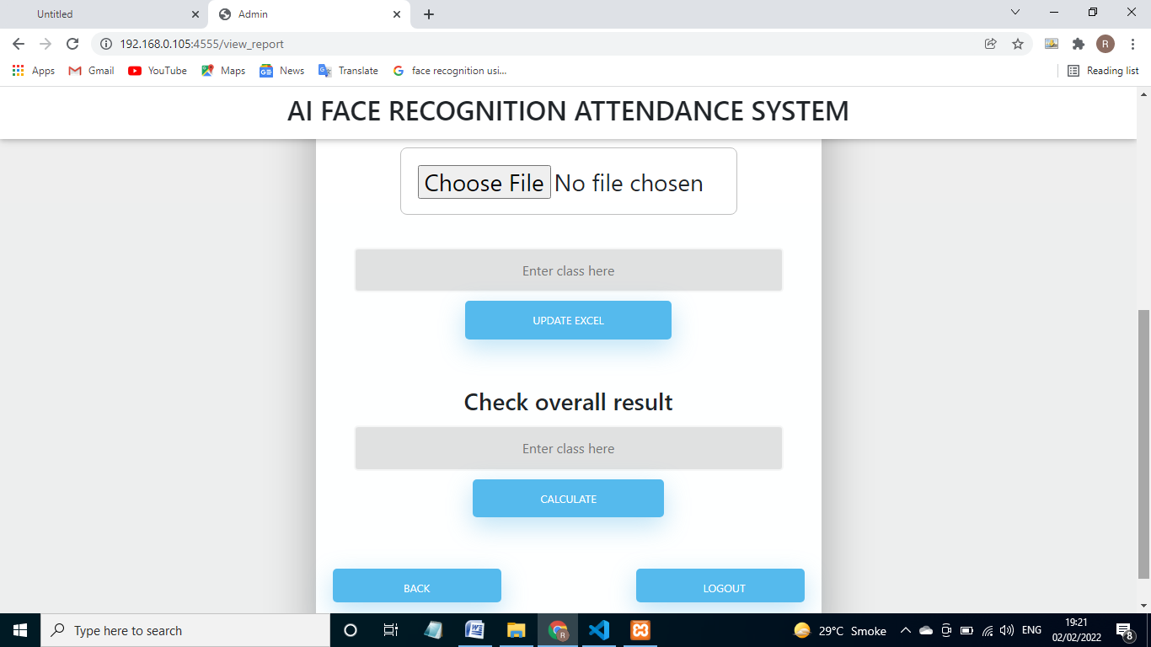

**4.3] Security Issues:-**

There is also a problem of spoof attack in face recognition i.e. someone will show someone's image of face through their mobile phone and trick our webapp and they will mark the attendace of their friends who were not present.

But I solved this issue using tensorflow, by training inception to detect mobile phones in an image then I used that model in the webapp as soon as student's click a snap it will first check if the face is spoof or original. To retrain inception's last layer I used 200 images of mobile phones and I feed them to tensorflow to retrain the last layer of inception.

**4.4] Test case Design:-**

|  |  |  |  |
| --- | --- | --- | --- |
| Test Condition | Input Selection | Expected | Actual |
| Admin Login | username=””  Password=”” | username and password fields are should not be empty | Login with super user Credentials |
| username=”admin” Password=”abc123” | Verify and redirect |  |
| Teacher Login | username=””  Password=”” | username and password fields are should not be empty | . Login with Register Credentials |
|  | username=”teacher” Password=”abc123” | Verify and redirect | Verify and redirect |

**4.5] Data Design:-**

**4.5.1 Schema Design:-**



**4.5.2 data Integrity and constraints.**

**Admin**

|  |  |  |  |
| --- | --- | --- | --- |
| Fields | Datatypes | Null | Value |
| username | Varchar | No | 30 |
| Password | varchar | No | 20 |

**Teacher Registration:-**

|  |  |  |  |
| --- | --- | --- | --- |
| Fields | Datatypes | Null | Value |
| Username/name | Varchar | No | 50 |
| Password | varchar | No | 50 |
| email | varchar | No | 50 |

**Student registration**

|  |  |  |  |
| --- | --- | --- | --- |
| Fields | Datatypes | Null | Value |
| Username/name | Varchar | No | 30 |
| Password | varchar | No | 50 |
| Student email | varchar | No | 50 |
| Parent email | varchar | No | 50 |
| Roll id | varchar | No | 10 |

**5] Implementation and Testing**

**5.1] Implementation Approach**.

**List of Modules:-**

**Admin module:-**

1. Login module
2. Signup panel
3. Student panel:-

Upload file

1. logout

**Teacher module:-**

1. teacher login
2. attendance panel
3. view report
4. view excel
5. send mail
6. logout

**Admin Module:- login module, Signup panel, Student panel, logout**

admin should register the students details such as his name email address and also create training data of each student by entering his roll id and taking snaps of his or her frontal face and then webapp will automatically create model for that particular roll id and save it on server, The model which is created for each student is about 8kb in size. Admin can also register teachers using this site.

**Teacher Module:- teacher login , Attendance panel, view report, logout**

After teacher login you can see there are three tabs one for attendance panel ,other is view report panel . In the view report module I am having 2 sub modules. One is view excel sheet and send mail notifications module. And last is logout module.

**Attendance panel:-** After going to attendance tab teacher will pass phone to student and they have to show their face to mark their attendance one by one. If face is matched with the model saved for the particular roll id attendance is marked.

**Note:- There is also problem that student can mark their friends attendance by showing their photo from mobile i.e. spoof attack.**

**For spoof detection I am using tensorflow inception model by retraining it's last layer so that it can detect mobile phones in an image.**

**View Report:-** after going to View report tab teacher need to enter date,time and class then teacher can see the attendance and can also download the excel. Teacher can also see that how many lecture each student is present from that particular class.

**Note:- To generate and manage excel I am using xlrx and xlrd and pandas.**

**Send mail:-** teacher can also send mail after attendance for that particular day is over for particular class.

**Note:- For sending email's I am using flask-mail.**

**Technologies:-**

**Hardware**

|  |  |
| --- | --- |
| Processor | Intel@ Pentium quad core |
| Memory | 4GB |
| ROM | 1TB |

**Software:-**

|  |  |
| --- | --- |
| IDE | VsCode |
| Language | Html+Css+JavaScript+Python+Flask |
| Database | Mysql |
| Operating system | Windows 10 |

**Timelines:-**

|  |  |  |
| --- | --- | --- |
| Start date | Duration | Module name |
| 16 /12/2021 | 4 days | Admin login page |
| 21/12/2021 | 5 days | Admin Signup page |
| 27/01/22 | 10 days | Student panel and upload file |
| 08/01/22 | 2 days | Teacher login |
| 11/01/22 | 10 days | Attendance panel(face detection) |
| 22/01/22 | 10 days | View report page(view excel) |
| 03/01/22 | 2 days | Send mail |

**5.2] Code details and code efficiency**

**Admin-site**

**App.py**

from flask import Flask,render_template,request,redirect,url_for,session

import MySQLdb

import os

#import for face recongition

from math import sqrt

from sklearn import neighbors

from os import listdir

from os.path import isdir, join, isfile, splitext

import pickle

from PIL import Image, ImageFont, ImageDraw, ImageEnhance

import face_recognition

from face_recognition import face_locations

from face_recognition.face_recognition_cli import image_files_in_folder

app = Flask(__name__)

# getting the location of root directory of the webapp

APP_ROOT = os.path.dirname(os.path.abspath(__file__))

print(APP_ROOT)

#connecting Mysql

conn = MySQLdb.connect(host="localhost",user="root",password="",db="login_info")

#-------------linking navbars------------#

@app.route("/")

def index():

    return render_template("home.html")

@app.route("/index")

def AdminLoginPage():

    return render_template("index.html")

@app.after_request

def set_response_headers(response):

    response.headers['Cache-Control'] = 'no-cache, no-store, must-revalidate'

    response.headers['Pragma'] = 'no-cache'

    response.headers['Expires'] = '0'

    return response

@app.route("/signup")

def AdminSignupPage():

    return render_template("Registration.html")

@app.after_request

def set_response_headers(response):

    response.headers['Cache-Control'] = 'no-cache, no-store, must-revalidate'

    response.headers['Pragma'] = 'no-cache'

    response.headers['Expires'] = '0'

    return response

@app.route("/contact")

def AdminTaskPage():

    return render_template("contact.html")

@app.route("/Registration")

def BackToHome():

    return render_template("home.html")

@app.route("/upload")

def Logout():

    return render_template("home.html")

#---------------#----------------------#

#database

@app.route('/login',methods=['POST'])

def login():

    user = str(request.form["user"])

    paswd = str(request.form["password"])

    cursor = conn.cursor()

    result = cursor.execute("SELECT * from admin_login where binary username=%s and binary password=%s",[user,paswd])

    if(result is 1):

        return render_template("upload.html")

    else:

        return render_template("index.html",msg="The username or password is incorrect")

@app.route('/signup_teacher',methods=['POST'])

def signup():

    user = str(request.form["user"])

    paswd = str(request.form["password"])

    email = str(request.form["email"])

    cursor = conn.cursor()

    result = cursor.execute("SELECT * from teacher_login where binary username=%s",[user])

    print (result)

    if(result == 1):

        return render_template("signup.html",title="SignUp",uname=user,msg="already present")

    cursor.execute("INSERT INTO teacher_login (username,password,email) VALUES(%s, %s, %s)",(user,paswd,email))

    conn.commit()

    return render_template("Registration.html",msg="successfully signup",uname=user)

@app.route('/signup_student',methods=['POST'])

def signup_student():

    user = str(request.form["student_name"])

    email = str(request.form["student_email"])

    roll_id = str(request.form["roll_id"])

    email1 = str(request.form["parent_email"])

    cursor = conn.cursor()

    result = cursor.execute("SELECT * from student_login where binary username=%s",[user])

    print (result)

    if(result == 1):

        return render_template("upload.html",uname=user,msg=" already present")

    cursor.execute("INSERT INTO student_login (username,student_email,parent_email,roll_id) VALUES(%s, %s, %s, %s)",(user,email,email1,roll_id))

    conn.commit()

    return render_template("upload.html",uname=user,msg=" successfully signup")

@app.route('/changetask',methods=['POST'])

def changetask():

    return render_template("home.html")

@app.route("/upload", methods=['POST'])

def upload():

    target = os.path.join(APP_ROOT,"train\\")

    if not os.path.isdir(target):

        os.mkdir(target)

    classfolder = str(request.form['class_folder'])

    session['classfolder'] = classfolder

    target1 = os.path.join(target,str(request.form["class_folder"])+"\\")

    session['target1']=target1

    print(target1)

    model = os.path.join(APP_ROOT,"model\\")

    if not os.path.isdir(model):

        os.mkdir(model)

    classname = str(request.form['class_folder']+"\\")

    model = os.path.join(model,classname)

    if not os.path.isdir(model):

        os.mkdir(model)

    session['model']=model

    session['classname'] = classname

    if not os.path.isdir(target1):

        os.mkdir(target1)

    id_folder = str(request.form["id_folder"])

    session['id_folder']= id_folder

    target2 = os.path.join(target1,id_folder+"\\")

    if not os.path.isdir(target2):

        os.mkdir(target2)

    target3 = os.path.join(target2,id_folder+"\\")

    if not os.path.isdir(target3):

        os.mkdir(target3)

    for file in request.files.getlist("file"):

        print(file)

        filename = file.filename

        destination = "\\".join([target3,filename])

        print(destination)

        file.save(destination)

    return call_train()

def call_train():

    id_folder = str(session.get('id_folder'))

    model=str(session.get('model'))

    if not os.path.isdir(model + id_folder):

        os.mkdir(model + id_folder)

    model = model + id_folder + "\\"

    model = model + "model"

    target1=str(session.get('target1'))

    print(id_folder)

    print (target1)

    target1 = target1 +id_folder

    print(target1)

    print(model)

    return train(train_dir=target1,model_save_path=model)

def train(train_dir, model_save_path = "", n_neighbors = None, knn_algo = 'ball_tree', verbose=True):

    id_folder=str(session.get('id_folder'))

    X = []

    y = []

    z = 0

    for class_dir in listdir(train_dir):

        if not isdir(join(train_dir, class_dir)):

            continue

        for img_path in image_files_in_folder(join(train_dir, class_dir)):

            image = face_recognition.load_image_file(img_path)

            faces_bboxes = face_locations(image)

            if len(faces_bboxes) != 1:

                if verbose:

                    print("image {} not fit for training: {}".format(img_path, "didn't find a face" if len(faces_bboxes) < 1 else "found more than one face"))

                    os.remove(img_path)

                    z = z + 1

                continue

            X.append(face_recognition.face_encodings(image, known_face_locations=faces_bboxes)[0])

            y.append(class_dir)

    print(listdir(train_dir+"\\"+id_folder))

    train_dir_f = listdir(train_dir+"\\"+id_folder)

    for i in range(len(train_dir_f)):

        if(train_dir_f[i].startswith('.')):

            os.remove(train_dir+"\\"+id_folder+"\\"+train_dir_f[i])

    print(listdir(train_dir+"\\"+id_folder))

    if(listdir(train_dir+"\\"+id_folder)==[]):

        return render_template("upload.html",msg1="training data empty, upload again")

    elif(z >= 1):

        return render_template("upload.html",msg1="Data trained for "+id_folder+", But one of the image not fit for trainning")

    if n_neighbors is None:

        n_neighbors = int(round(sqrt(len(X))))

        if verbose:

            print("Chose n_neighbors automatically as:", n_neighbors)

    knn_clf = neighbors.KNeighborsClassifier(n_neighbors=n_neighbors, algorithm=knn_algo, weights='distance')

    knn_clf.fit(X, y)

    if model_save_path != "":

        with open(model_save_path, 'wb') as f:

            pickle.dump(knn_clf, f)

    return render_template("upload.html",msg1="Data trained for "+ id_folder)

if(__name__ == '__main__'):

    app.secret_key = 'secretkey'

    app.run(host="0.0.0.0",port=4555,debug=True)

**Teachers-site**

**App.py**

from flask import Flask,render_template,request,redirect,url_for,session

from flask_bootstrap import Bootstrap

import MySQLdb

import os

from math import sqrt

from sklearn import neighbors

from os import listdir

from os.path import isdir, join, isfile, splitext

import shutil

import pickle

from PIL import Image, ImageFont, ImageDraw, ImageEnhance

import face_recognition

from face_recognition import face_locations

from face_recognition.face_recognition_cli import image_files_in_folder

from datetime import datetime,timedelta

from pytz import timezone

import xlsxwriter

import pandas as pd

from glob import glob

from flask_mail import Mail, Message

from io import BytesIO

import base64

import lable_image

from flask import send_from_directory

app = Flask(__name__)

# mail settings

app.config.update(

    DEBUG = True,

    #Email settings

    MAIL_SERVER = 'smtp.gmail.com',

    MAIL_PORT = 465,

    MAIL_USE_SSL = True,

    MAIL_USERNAME = 'rameshchauhan00000007@gmail.com',

    MAIL_PASSWORD = '7715865438',

    MAIL_DEFAULT_SENDER = 'rameshchauhan00000007@gmail.com'

    )

mail = Mail(app)

# declaring timezone then creating custom date format

india = timezone('Asia/Kolkata')

date = str(datetime.now(india))[:10] + "@" + str(datetime.now())[11:13] + "hrs"

# getting the location of root directory of the webapp

APP_ROOT = os.path.dirname(os.path.abspath(__file__))

#APP_ROOT = os.path.abspath(os.curdir)

print('Path =',APP_ROOT)

APP_ROOT1 = APP_ROOT.split('teachers_site')

print('Path=',APP_ROOT1)

# connection with mysql database using python package MySQLdb

conn = MySQLdb.connect(host="localhost",user="root",password="",db="login_info")

@app.route("/")

def home():

    return render_template("homepage.html")

@app.after_request

def set_response_headers(response):

    response.headers['Cache-Control'] = 'no-cache, no-store, must-revalidate'

    response.headers['Pragma'] = 'no-cache'

    response.headers['Expires'] = '0'

    return response

@app.route('/login',methods=['POST'])

def login():

    print(APP_ROOT)

    print(APP_ROOT1[0])

    user = str(request.form["user"])

    session['user'] = user

    paswd = str(request.form["password"])

    username = user.split(".",1)[0]

    username = str(username)

    print(username)

    print(type(username))

    cursor = conn.cursor()

    result = cursor.execute("SELECT * from teacher_login where binary username=%s and binary password=%s",[user,paswd])

    if(result is 1):

        return render_template("task.html",uname=username)

    else:

        return render_template("homepage.html",title="Faculty Login",msg="The username or password")

@app.after_request

def set_response_headers(response):

    response.headers['Cache-Control'] = 'no-cache, no-store, must-revalidate'

    response.headers['Pragma'] = 'no-cache'

    response.headers['Expires'] = '0'

    return response

@app.route('/upload_redirect',methods=['POST'])

def upload_redirect():

    if(os.path.isfile(APP_ROOT+"\\image.jpeg")):

        os.remove(APP_ROOT + "\\image.jpeg")

    return render_template("upload.html")

@app.route("/upload", methods=['POST'])

def upload():

    if not os.path.isfile(APP_ROOT+"\\image.jpeg"):

        return render_template("upload.html",msg="spoof detected")

    id_folder = str(request.form['id_folder'])

    session['id_folder']= id_folder

    target = os.path.join(APP_ROOT,"test\\")

    if not os.path.isdir(target):

        os.mkdir(target)

    target1 = os.path.join(target,str(request.form["folder_name"])+"\\")

    test_append = str(request.form["folder_name"])

    session['test_append']= test_append

    print(target1)

    if not os.path.isdir(target1):

        os.mkdir(target1)

    shutil.copyfile(APP_ROOT+"\\"+"image.jpeg",target1+"image.jpeg")

    destination = APP_ROOT + "\\" + "test\\" + test_append + "\\" + "image.jpeg"

    session['destination'] = destination

    teacher_name = str(session.get('user'))

    session['teacher_name'] = teacher_name

    #return render_template("upload.html",msg="uploaded successfully")

    return match()

@app.after_request

def set_response_headers(response):

    response.headers['Cache-Control'] = 'no-cache, no-store, must-revalidate'

    response.headers['Pragma'] = 'no-cache'

    response.headers['Expires'] = '0'

    return response

def match():

    destination = str(session.get('destination'))

    print(destination)

    if os.path.isfile(destination):

        test_append = str(session.get('test_append'))

        session['test_append'] = test_append

        id_folder = str(session.get('id_folder'))

        train_dir = APP_ROOT1[0]+"admin_site\\train\\"+ test_append

        try:

            model = APP_ROOT1[0]+"admin_site\\model\\"+test_append+"\\" + id_folder + "\\" +"model"

            print(model)

            return predict1(model)

        except FileNotFoundError:

            os.remove(APP_ROOT1[0]+"teachers_site\\image.jpeg")

            return render_template("upload.html",msg="trained model not present for " + test_append + ": "+id_folder)

def predict(X_img_path, knn_clf = None, model_save_path ="", DIST_THRESH = .45):

    if knn_clf is None and model_save_path == "":

        raise Exception("must supply knn classifier either thourgh knn_clf or model_save_path")

    if knn_clf is None:

        with open(model_save_path, 'rb') as f:

            knn_clf = pickle.load(f)

    X_img = face_recognition.load_image_file(X_img_path)

    X_faces_loc = face_locations(X_img)

    if len(X_faces_loc) == 0:

        return []

    faces_encodings = face_recognition.face_encodings(X_img, known_face_locations=X_faces_loc)

    closest_distances = knn_clf.kneighbors(faces_encodings, n_neighbors=1)

    is_recognized = [closest_distances[0][i][0] <= DIST_THRESH for i in range(len(X_faces_loc))]

    return [(pred) if rec else ("unknown") for pred, rec in zip(knn_clf.predict(faces_encodings), is_recognized)]

def predict1(model):

    test_append = str(session.get('test_append'))

    test_dir = APP_ROOT1[0]+"teachers_site\\test\\" + test_append

    f_preds = []

    for img_path in listdir(test_dir):

        preds = predict(join(test_dir, img_path) ,model_save_path=model)

        f_preds.append(preds)

        print(f_preds)

    print(len(preds))

    print(len(f_preds))

    for i in range(len(f_preds)):

        if(f_preds[i]==[]):

            os.remove(APP_ROOT1[0]+"teachers_site\\image.jpeg")

            return render_template("upload.html",msg="upload again, face not found")

        else:

            os.remove(APP_ROOT1[0]+"teachers_site\\image.jpeg")

    excel = os.path.join(APP_ROOT,"excel\\")

    if not os.path.isdir(excel):

        os.mkdir(excel)

    excel1 = os.path.join(excel,test_append)

    if not os.path.isdir(excel1):

        os.mkdir(excel1)

    teacher_name = str(session.get('teacher_name'))

    excel2 = os.path.join(excel1,teacher_name)

    if not os.path.isdir(excel2):

        os.mkdir(excel2)

    session['excel2'] = excel2

    excel3 = excel2+"\\"+date+'.xlsx'

    if not os.path.isfile(excel3):

        workbook = xlsxwriter.Workbook(excel2+"\\"+date+'.xlsx')

        worksheet = workbook.add_worksheet()

        worksheet.set_column(0,0,20)

        worksheet.write('A1','Roll Id')

        f_preds.sort()

        row = 1

        col = 0

        for i in range(len(f_preds)):

            for j in range(len(f_preds[i])):

                worksheet.write_string(row,col,f_preds[i][j])

                row += 1

        workbook.close()

        return render_template("upload.html",msg= f_preds[0][0] + " present")

    else:

        df = pd.read_excel(excel2+"\\"+date+'.xlsx')

        writer = pd.ExcelWriter(excel2 + "\\" + date+'.xlsx')

        df.to_excel(writer,sheet_name="Sheet1",index=False)

        workbook  = writer.book

        worksheet = writer.sheets['Sheet1']

        rows=df.shape[0]

        worksheet.write_string(rows+1,0,f_preds[0][0])

        writer.save()

        df = pd.read_excel(excel2+"\\"+date+'.xlsx')

        df.drop_duplicates(['Roll Id'],keep='first',inplace=True)

        result = df.sort_values("Roll Id")

        writer = pd.ExcelWriter(excel2 + "\\" + date+'.xlsx')

        result.to_excel(writer,'Sheet1',index=False)

        workbook = writer.book

        worksheet = writer.sheets['Sheet1']

        worksheet.set_column(0,0,20)

        writer.save()

        return render_template("upload.html",msg= f_preds[0][0] + " present")

@app.route('/view_report',methods=['POST'])

def view_report():

    return render_template("excel.html")

# view route to download excel files

@app.route('/view',methods=['POST'])

def view():

    test_append = str(request.form['folder_name'])

    session['test_append']=test_append

    teacher_name = str(session.get('user'))

    excel_dir = APP_ROOT+"\\excel\\"+test_append+"\\"+teacher_name+"\\"

    excel_date = request.form['fname']

    time = request.form['ftime']

    time = time[:2]

    print(time)

    final_excel=glob(excel_dir + "\\" + excel_date+ "@" + time +"*.xlsx")[0]

    print(final_excel)

    df = pd.read_excel(final_excel)

    df.index += 1

    return render_template("files.html",msg=final_excel,df=df,date=excel_date+"@"+time+"hrs")

@app.route('/excel/<path:filename>', methods=['POST'])

def download(filename):

    return send_from_directory(directory='excel', filename=filename)

# route to send emails to parents and students

@app.route('/send_mail',methods=['POST'])

def send_mail():

    test_append = str(request.form['folder_name'])

    teacher_name = str(session.get('user'))

    excel_dir = APP_ROOT+"\\excel\\"+test_append+"\\"+teacher_name+"\\"

    excel_date = request.form['fname']

    time = request.form['ftime']

    time = time[:2]

    final_send = glob(excel_dir + "\\" + excel_date+ "@" + time +"*.xlsx")[0]

    print(final_send)

    df = pd.read_excel(final_send)

    roll_id = list(df['Roll Id'])

    print(type(roll_id))

    print(roll_id)

    cursor = conn.cursor()

    for i in range(len(roll_id)):

        cursor.execute("SELECT student_email,parent_email from student_login where binary roll_id=%s",[roll_id[i]])

        email = list(cursor.fetchone())

        print(type(email[1]))

        print(email[0])

        print(email[1])

        msg = Message('Auto Generated',recipients= [email[0],email[1]])

        msg.body = "Hi.. " + roll_id[i] + " is present for the lecture of " + "Prof. " +str(teacher_name.split('.',1)[0]) + ", which is held on " + excel_date + "@" + time + "hrs"

        msg.html = "Hi.. " + roll_id[i] + " is present for the lecture of " + "Prof. " +str(teacher_name .split('.',1)[0])+ ", which is held on " + excel_date + "@" + time + "hrs"

        mail.send(msg)

    return "<h1>mail sent<h1>"

#.........update attendance .......#

@app.route('/update',methods=['POST'])

def update():

    test_append = str(request.form['excel_folder'])

    print(test_append)

    teacher_name = str(session.get('user'))

    print(teacher_name)

    excel_dir = APP_ROOT + "\\excel\\" + test_append + "\\" + teacher_name + "\\"

    print(excel_dir)

    for file in request.files.getlist("updated_excel"):

        print(file)

        filename = file.filename

        print(filename)

        destination = "\\".join([excel_dir,filename])

        print(destination)

        file.save(destination)

    return render_template("excel.html",msg="updated successfully")

@app.route('/calculate',methods=['POST'])

def calculate():

    test_append = str(request.form['final_class'])

    print(test_append)

    teacher_name = str(session.get('user'))

    print(teacher_name)

    excel_root = APP_ROOT + "\\excel\\" + test_append + "\\" + teacher_name + "\\"

    print(excel_root)

    excel_names = os.listdir(excel_root)

    print(excel_names)

    for i in range(len(excel_names)):

        if excel_names[i].startswith("."):

            os.remove(excel_root+excel_names[i])

        else:

            if os.path.isdir(excel_root+excel_names[i]):

                shutil.rmtree(excel_root+excel_names[i], ignore_errors=False, onerror=None)

    excel_names = os.listdir(excel_root)

    if(excel_names==[]):

        return render_template("excel.html",msg1="No excel files found")

    for i in range(len(excel_names)):

        excel_names[i] = excel_root + excel_names[i]

    print(type(excel_names))

    # read them in

    excels = [pd.ExcelFile(name) for name in excel_names]

    # turn them into dataframes

    frames = [x.parse(x.sheet_names[0], header=None,index_col=None) for x in excels]

    # delete the first row for all frames except the first

    # i.e. remove the header row -- assumes it's the first

    frames[1:] = [df[1:] for df in frames[1:]]

    # concatenate them..

    combined = pd.concat(frames)

    if not os.path.isdir(excel_root+"final\\"):

        os.mkdir(excel_root + "final\\")

    final = excel_root + "final\\"

    print(final)

    # write it out

    combined.to_excel(final+"final.xlsx", header=False, index=False)

    # below code is to find actual repetative blocks

    workbook = pd.ExcelFile(final+"final.xlsx")

    df = workbook.parse('Sheet1')

    sample_data = df['Roll Id'].tolist()

    print (sample_data)

    #a dict that will store the poll results

    results = {}

    for response in sample_data:

        results[response] = results.setdefault(response, 0) + 1

    finaldf = (pd.DataFrame(list(results.items()), columns=['Roll Id', 'Total presenty']))

    finaldf = finaldf.sort_values("Roll Id")

    print (finaldf)

    writer = pd.ExcelWriter(final+"final.xlsx")

    finaldf.to_excel(writer,'Sheet1',index=False)

    workbook  = writer.book

    worksheet = writer.sheets['Sheet1']

    worksheet.set_column(0,1,20)

    writer.save()

    final = final + "final.xlsx"

    session['final']=final

    final = final[91:]

    return viewfinal(final)

def viewfinal(final):

    test_append = str(session.get('test_append'))

    final_path = str(session.get('final'))

    df = pd.read_excel(final_path)

    df.index += 1

    return render_template("files.html",msg=final,course=test_append,df=df)

@app.route('/changetask',methods=['POST'])

def changetask():

    return render_template("task.html")

@app.route('/logout',methods=['POST'])

def logout():

    return render_template("index.html",title="Faculty Login",msg1="Logged out please login again")

@app.route('/hello',methods=['POST'])

def hello():

    data_url = request.values['imageBase64']

    data_url= data_url[22:]

    im = Image.open(BytesIO(base64.b64decode(data_url)))

    print(type(im))

    im.save('image.jpeg')

    filepath = APP_ROOT + "\\" + "image.jpeg"

    var = lable_image.function(filepath)

    print(var)

    for i in range(len(var)):

        if(var[i] > 0.8):

            os.remove(filepath)

    return ''

if(__name__ == '__main__'):

    app.secret_key = 'super secret key'

    app.run(host="0.0.0.0",port=4555,debug=True)

**Label-image.py**

# This requires retrained_labels.txt and retrained_graph.pb files which are available at this link.

# https://drive.google.com/open?id=1TMCTLEqekAh1zMwdSfWFxMKNKYyfgIYB

# https://drive.google.com/open?id=1d93B2ehbxrpbAhm7OqtvgDT5Mszk4_jc

# Change both file path accordingly.

import tensorflow as tf,sys

import os

APP_ROOT = os.path.dirname(os.path.abspath(__file__))

print('path=',APP_ROOT)

def function(xyz):

    output = []

    image_path = xyz

    image_data = tf.io.gfile.GFile(image_path,'rb').read()

    label_lines = [line.rstrip() for line

                            in tf.io.gfile.GFile(APP_ROOT +"\\tensor\\tf_files\\retrained_labels.txt")]

    with tf.io.gfile.GFile(APP_ROOT +"\\tensor\\tf_files\\retrained_graph.pb",'rb') as f:

        graph_def = tf.compat.v1.GraphDef()

        graph_def.ParseFromString(f.read())

        _ = tf.import_graph_def(graph_def,name='')

    with tf.compat.v1.Session() as sess:

        softmax_tensor = sess.graph.get_tensor_by_name('final_result:0')

        predictions = sess.run(softmax_tensor, \

            {'DecodeJpeg/contents:0': image_data})

        top_k = predictions[0].argsort()[-len(predictions[0]):][::-1]

        i = 0

        for node_id in top_k:

            human_string = label_lines[node_id]

            score = predictions[0][node_id]

            print('%s (score = %.5f)' % (human_string,score))

            output.append(score)

    return output

**5.3] Testing approach:-**

A test approach is the test strategy implementation of a project, defines how testing would be carried out.

**5.3.1 Unit Testing:-**

All the modules like registration, login, image snapshot, face detection, face cam recognition and attendance record page will be test individual.

**5.3.2 Integration Testing:-**

In integration testing we are checking after successful registration teacher also able login into the webapp. Here we are checking once admin register teacher and student details will get store into Mysql database. Basically here we are checking all the modules are connected or not with each other.

**5.3.3 System Testing:-**

Here we are checking whatever input we are giving to the system and we are getting according output or not. Also The whole system working properly or not.

**5.3.4 Validating Testing:-**

Validation testing can be defined in many ways, but a simple definition is that validation succeeds when the software function in a manner that can be reasonably expected by the Users.

**5.3.5 Output Testing:-**

After performing the validation testing the next test is output testing of the proposed system since no system could be useful if it does not produce the required output in the specified format. Asking the user about the format required by them tests the outputs generated or displayed by the system under consideration. The output format on the screen is found to be correct as the format was designed in the system phase according to the user’s needs. Hence, output testing does not result in any correction in the system.

**5.3.6 User Acceptance Testing:-**

User acceptance of a system is the key factory for the success of any system. The system under consideration is tested for user acceptance by constantly keeping in touch with the perspective system.

**5.4] Modifications and Improvement**

After testing and finding all errors, exceptions and bugs, errors were solved by troubleshooting, exceptions were handled by try catch block at the correct places avoiding redundancy of code from model class. Bugs can never be removed completely but most of them are solved and remaining are under development.

6] **RESULTS AND DISCUSSION**

**6.1] User Documentation:-**

There are mainly two webapps for this project one is say admin site and other one is teacher's site.

The whole concept is at the time of admission to college or school admin should register the students details such as his name email address and also create training data of each student by entering his roll id and taking snaps of his or her frontal face and then webapp will automatically create model for that particular roll id and save it on server, The model which is created for each student is about 8kb in size. Admin can also register teachers using this site.

Now using teacher's site (It will be used when teacher will actually enter the class), teacher has to login first and then after clicking on attendance tab there will be no back button as teacher will pass on the phone to student.

Student's will then have to just click a snap enter class and roll id and press enter to mark their attandance.

After that there is also a problem of spoof attack in face recognition i.e. someone will show someone's image of face through their mobile phone and trick our webapp and they will mark the attendace of their friends who were not present.

But I solved this issue using tensorflow, by training inception to detect mobile phones in an image then I used that model in the webapp as soon as student's click a snap it will first check if the face is spoof or original. To retrain inception's last layer I used 200 images of mobile phones and I feed them to tensorflow to retrain the last layer of inception. To do this follow <https://codelabs.developers.google.com/codelabs/tensorflow-for-poets/#0> To download 200 images at once use fatkun-batch-download chrome extension.

Now after student's part is done. Teacher can then login again and then go to report's tab to see attendance. Here there are several option's I have given.

If teacher want to see today's attendace, just select date and time to see the attendance. And there is also an option to download the attendace sheet in excel form and then again reupload it after making any changes if sometime required by the teacher. And the teacher can also see total attendance for his or her lecture. so that they can analyze how many lectures each student from particular class had attended so far.

One additional feature is that teacher can send email for the attendance marked to all the parents as well as students by selecting class and clicking on send mail button.

**Admin Site**

**Homepage**





**Teacher Registration page:-**



**Contact Page:-**





**Admin login Page**



**Student Registration and Model Training Page**





**Database:-**

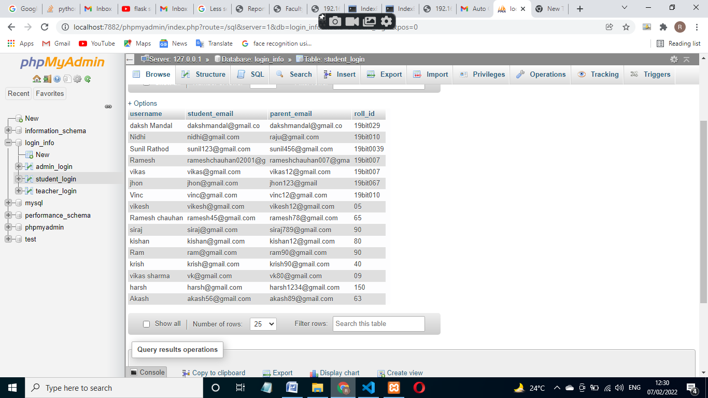

**Admin Login**

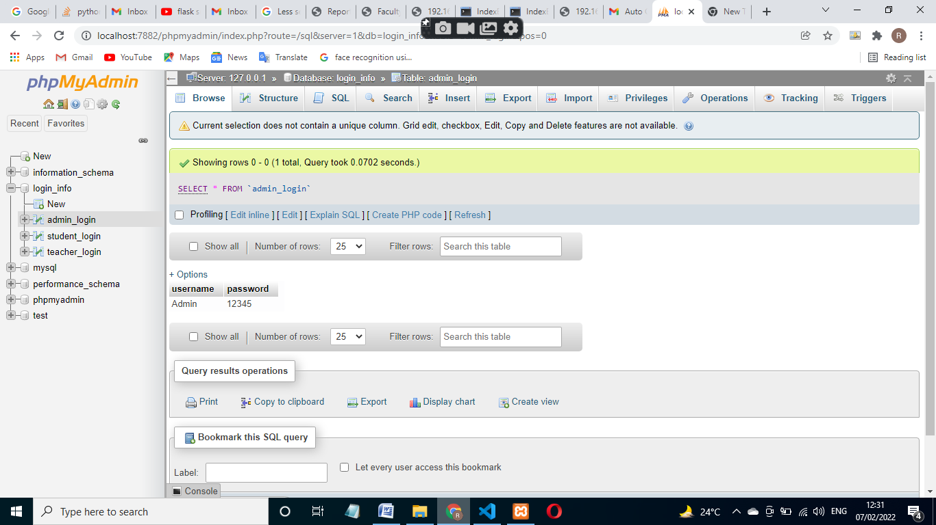

**Teacher Registration:-**

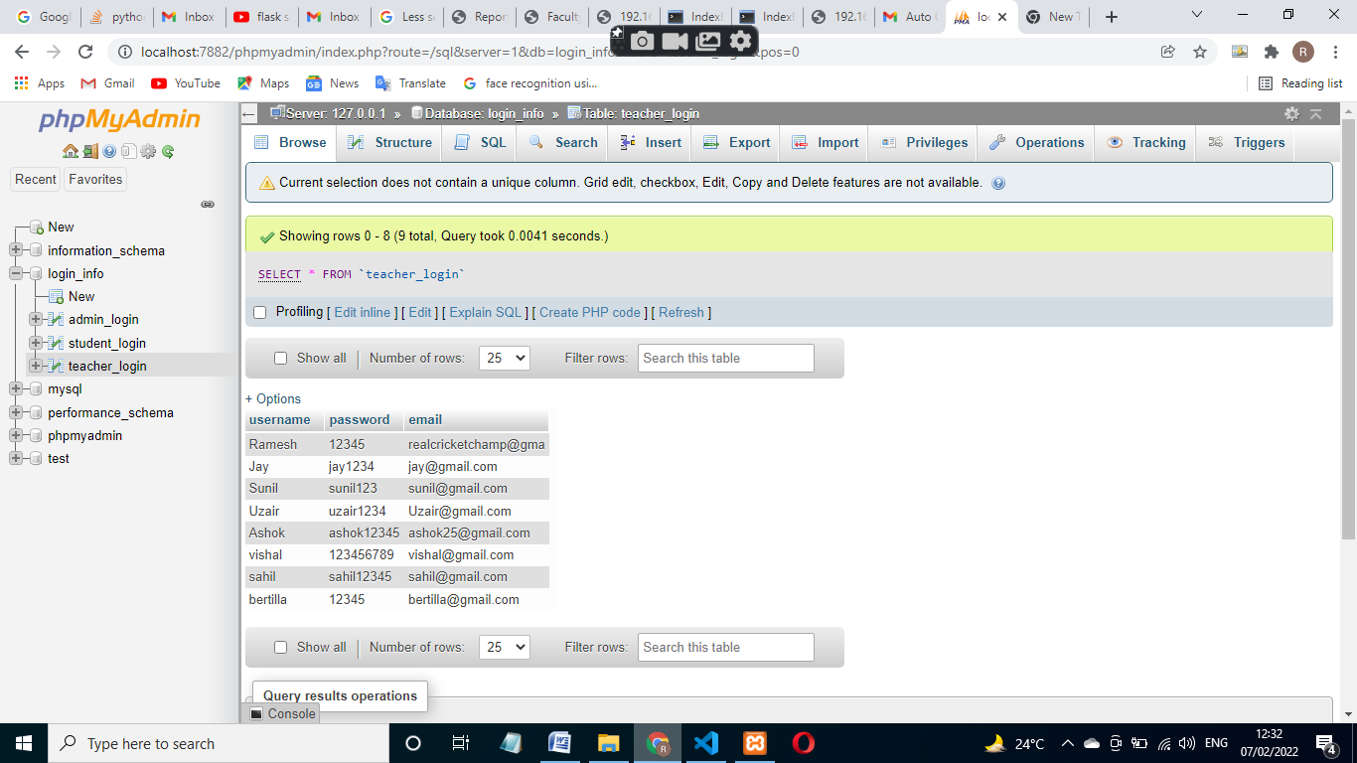

**Student registration:-**

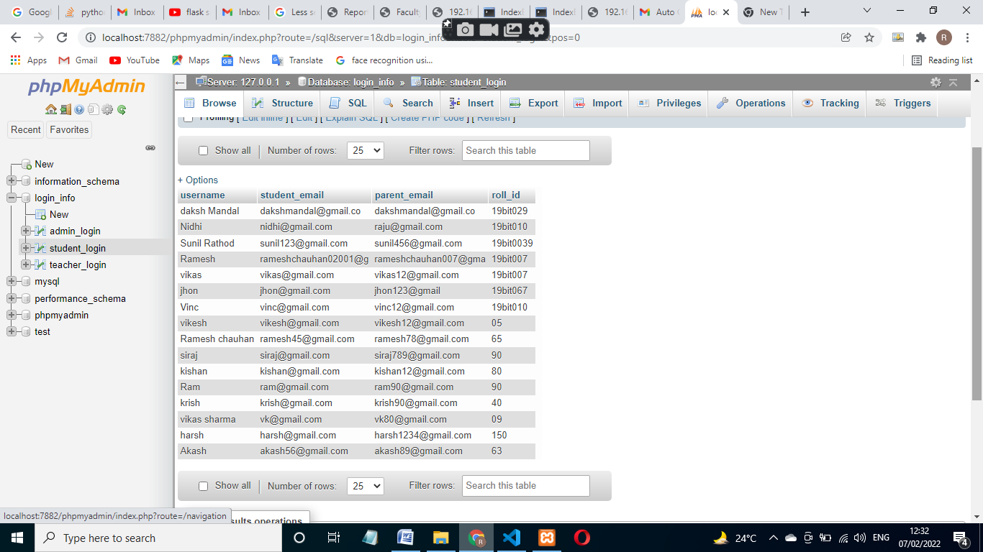

**Teachers Site:**

**Homepage:**





**LoginPage:**



**TaskPage:**











**AttendancePage:**





**View Report Page:**





**Excel sheet:-**

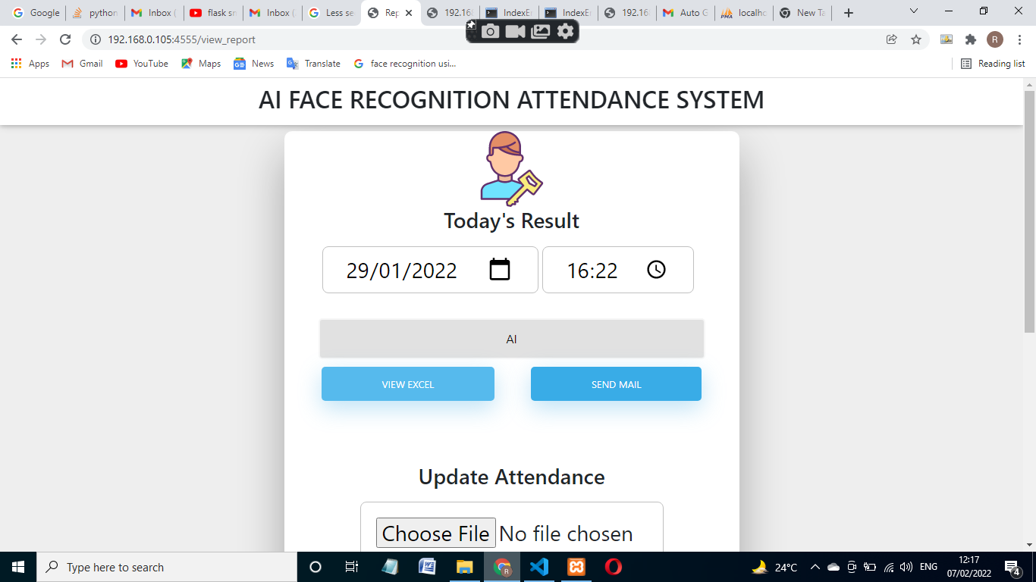

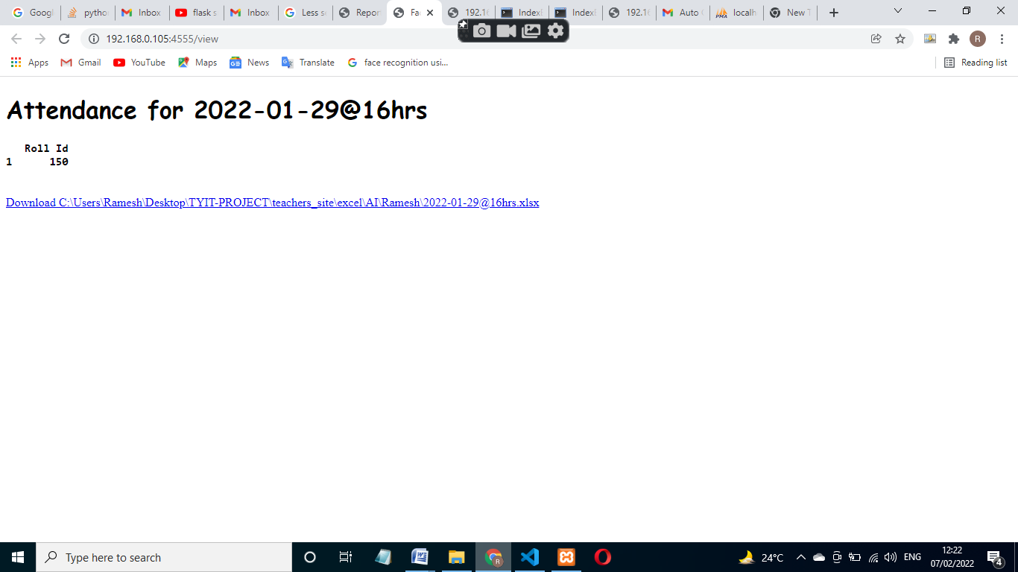

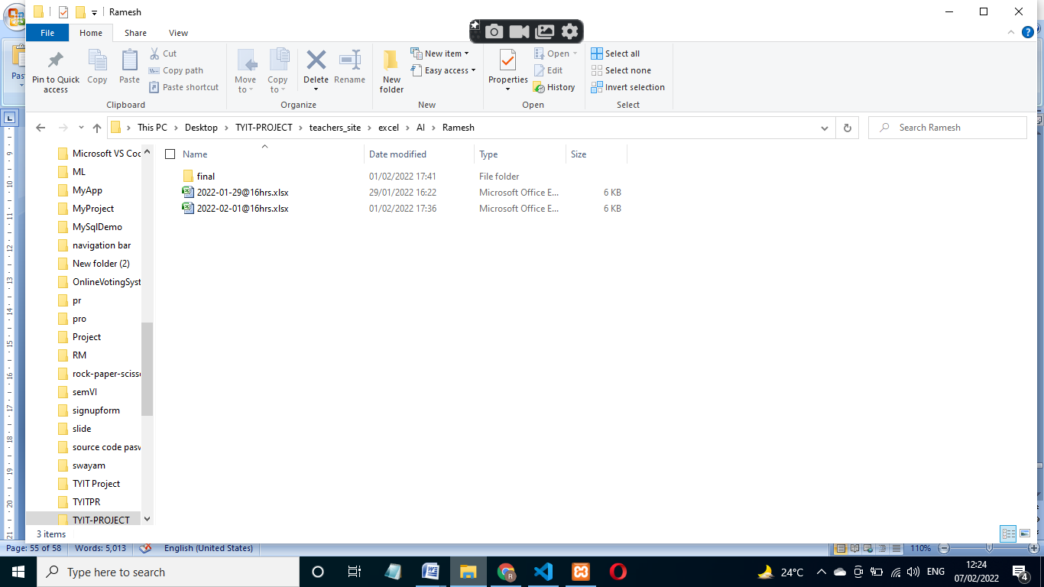

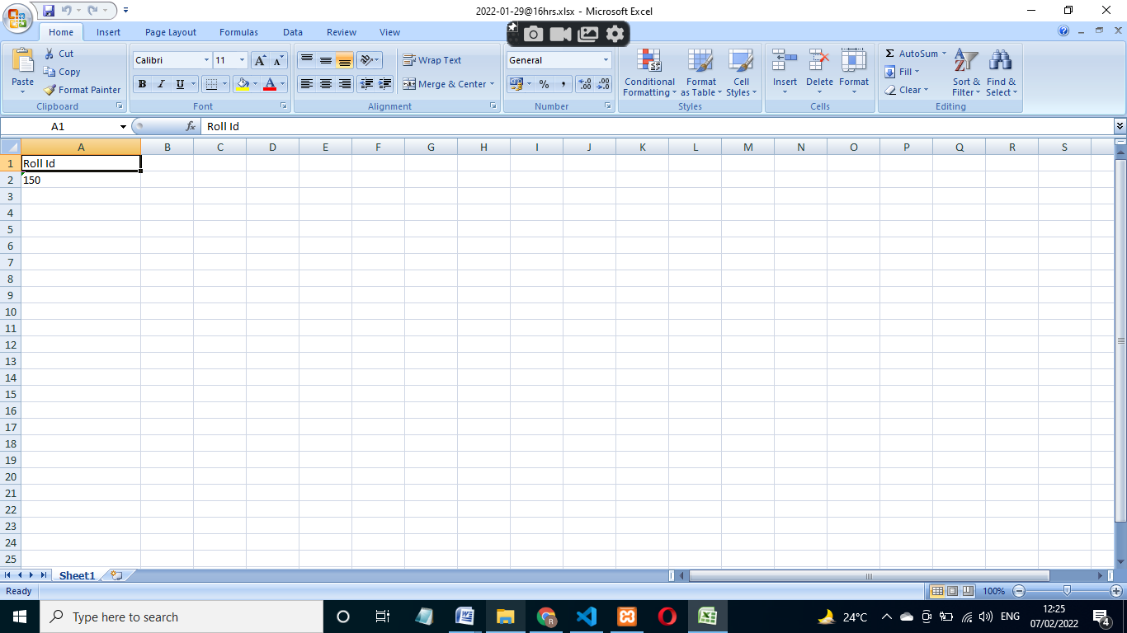

**Final xlsx:-**

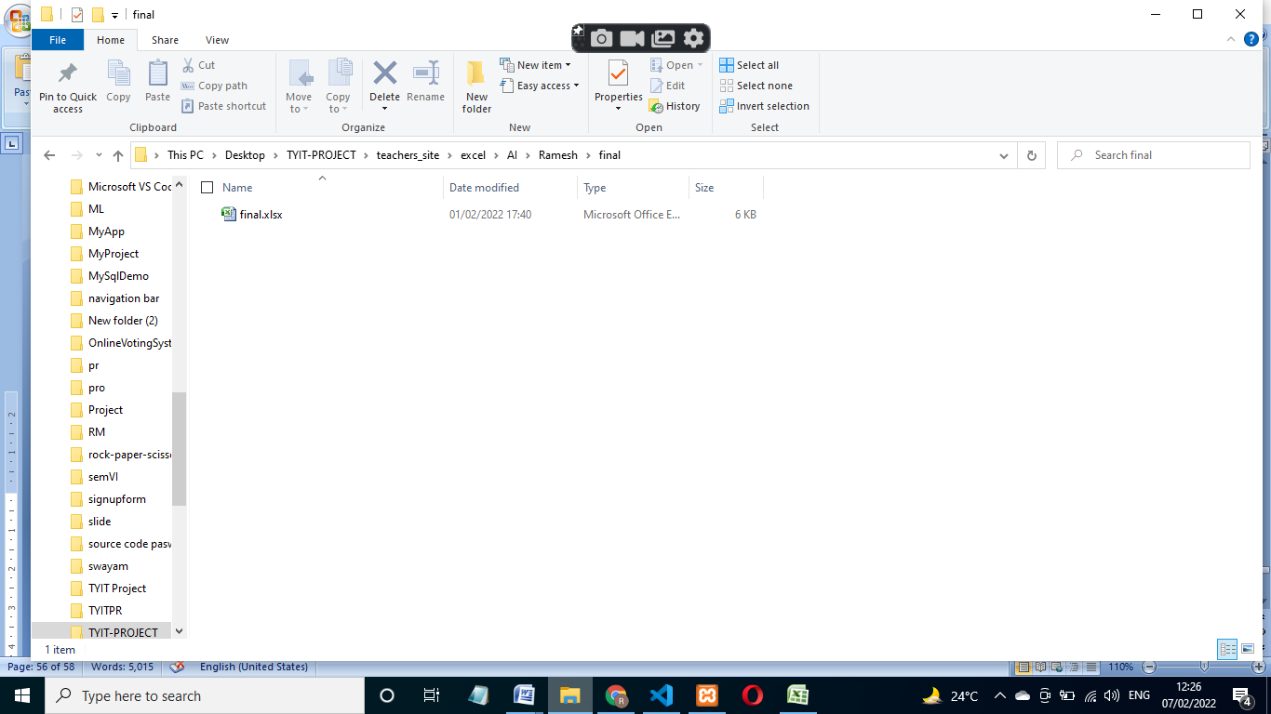

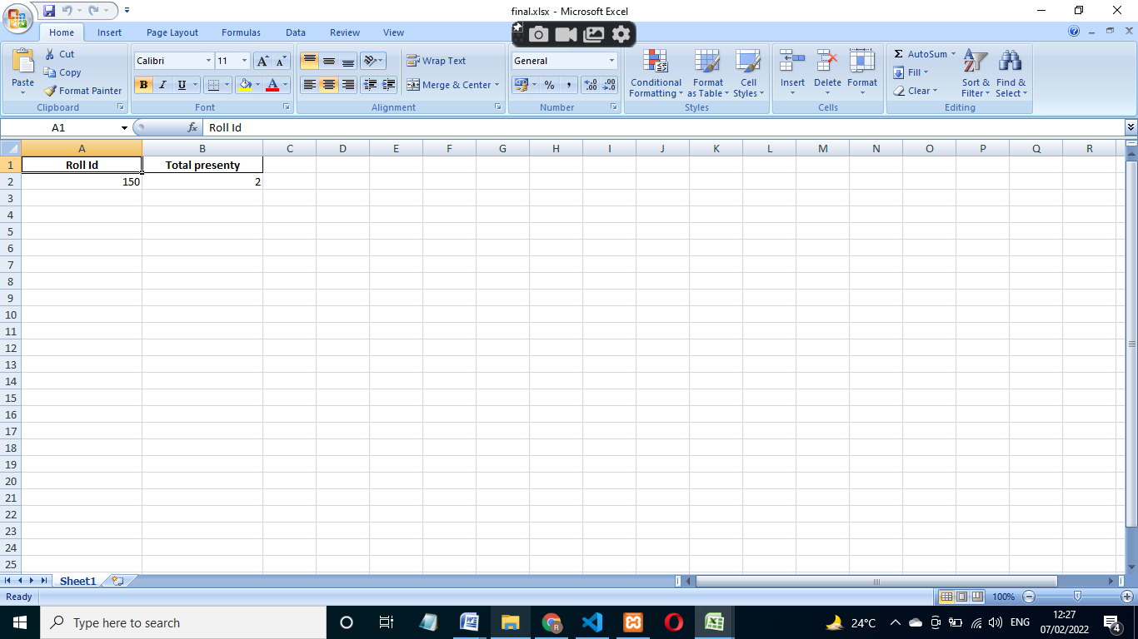

**Send mail:-**



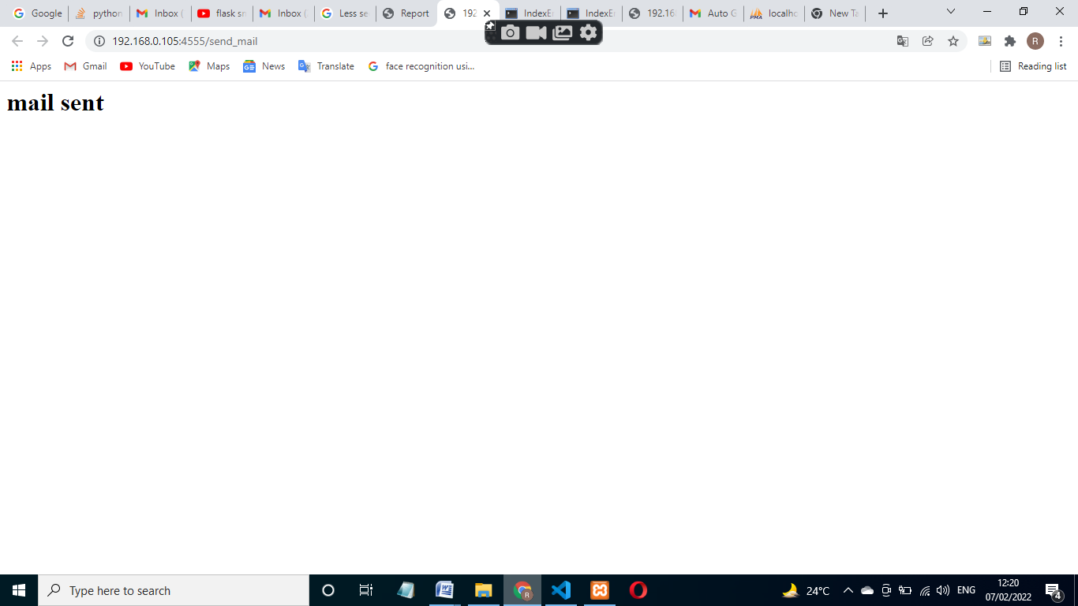

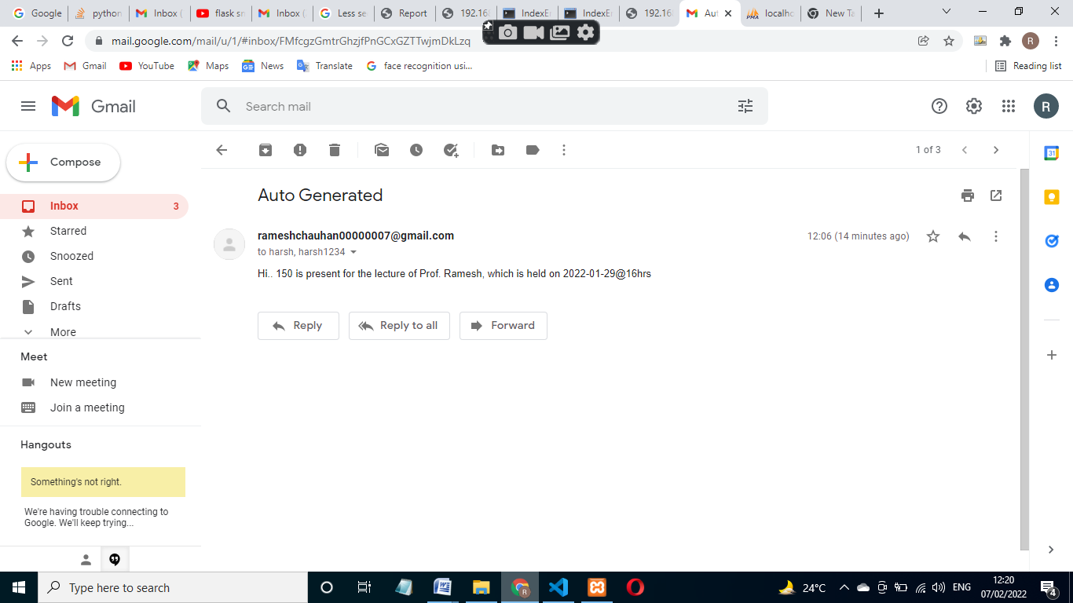

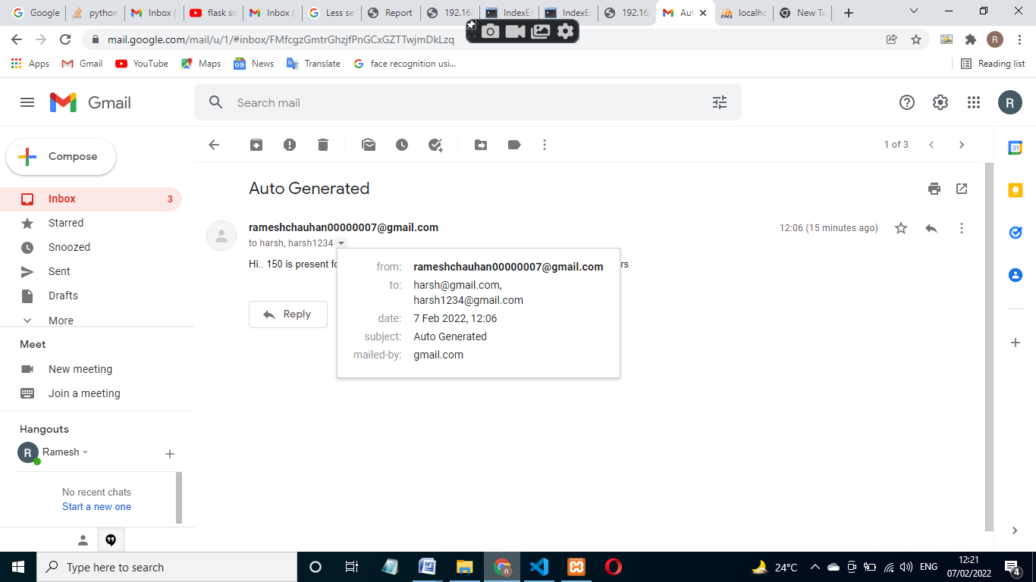

**7] Conclusion:-**

**7.1] Conclusion:-**

The goal of the project was to build a facial recognition system for student’s attendance. The result of the project was a successful prototype of a facial recognition system where the admin can create a teacher account and add students and their information to the database. Teachers then can log in to the system and take attendance of the student. The student’s face is detected by a camera and attendance is recorded in the database. Teachers and admin could see the attendance report of the students. From experiment, I noticed the face recognition was sensitive to face background, light, and head orientations. This technique described the accurate and efficient method of automatic attendance in the classroom which could replace the traditional method. An automatic attendance has many advantages, most of the existing systems are time consuming and require semi manual interference from lecturers, and our system seeks to solve these issues by using face recognition in the process to save the time and labor. And No need for installing complex hardware for taking the attendance in classroom, all we need is a camera and laptop. We used algorithms that can detect and recognize faces in the image.

**7.2. Limitation:-**

* The identical twin issue. I am having a challenge of getting different recognitions for twins.

**7.3. Future Scope of the Project:-**

* Automatic attendance system can be improved by increasing the number of features which can be extracted to increase accuracy of face recognition.
* Automating the whole process so that we have digital environment.
* Use the Live face Recognition to recognize each individual and mark their attendance automatically.
* Utilizes video and image processing to provide input to the system
* Automate update in the attendance sheet without human intervention.
* To keep the student update with their attendance ratio.